Media Relations Office
Communications Group
The Open University
Milton Keynes
United Kingdom
MK7 6AA
t +44 (0)1908 653343
f +44 (0)1908 652247
e Press-office@open.ac.uk
w www.open.ac.uk/media/




News

For the attention of: Education/Feature writers
Friday May 4 2007 [PR5293]

Visit Coast for the third time with The Open University and BBC TWO
Tx: 8pm, BBC Two, Sunday May 13 2007
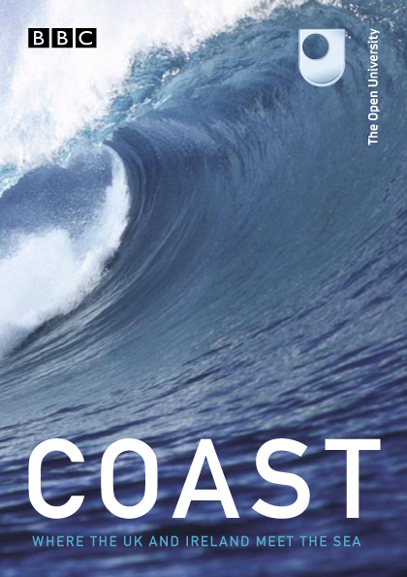
The BAFTA and VLV award-winning series Coast, co-produced by The Open University, returns to BBC TWO for the third time with eight brand-new episodes which will take in even more wonderful sights and stories from the length and breadth of the UK, Ireland and islands.
For the first time, the team will be visiting the northern-most tip of the British Isles - Shetland, the continental charms of the Channel Islands and the fiercely independent Isle of Man. They will explore the spectacular south west of Ireland for the first time as well as returning to some favourite old haunts to tell new stories such as the south of England’s fabulous Jurassic Coast which features some of the most expensive coastal property in the world and the south coast of Wales including the Gower Peninsula, the first area of outstanding natural beauty in Britain. The team travel to East Anglia and the east coast of Scotland where the team investigate Edinburgh’s many links to the coast.
Neil Oliver remains the main presenter for the final series and will again be joined by Nick Crane, Dr Alice Roberts, Miranda Krestovnikoff and Mark Horton. The team will also be joined in the latest leg of their journey by Hermione Cockburn of The Open University and engineer Dick Strawbridge.
Hermione Cockburn says: “Working on Coast has been absolutely brilliant – the reception from the public wherever we were filming was so warm and friendly, there’s a lot of goodwill towards the series. In Blackpool, we needed to cross a building site with no entry signs everywhere but one mention of Coast and we were personally escorted through by the site manager!
“One of the stories I present is about secret WW2 listening stations on the Norfolk coast. It was fascinating to experiment with the technology behind these stations with the help of scientists from the OU. But it was even more enthralling to meet an elderly woman, Joy Hale, who’d actually worked there and hear her stories firsthand. Like Joy, my grandmother had been a WREN but had worked as a cipher officer - the next link in the chain of intelligence gathering. It was a poignant story to present and I’m pleased that almost forgotten pieces of history like this will be heard by a wider audience and preserved by Coast.”
Dr Alice Roberts says: “In the new series, my favourite story is the excavation at Sandwick Bay in Shetland. I camped on the beach in my camper van, and was privileged to take a look at the Iron Age skeleton that had been discovered on the site.”
Miranda Krestovnikoff says: “My favourite coastal location from filming series 3 has to be the Guliot caves in Sark. These gems are something I might explore as a diver - rocks encrusted in jewel anemones of all different colours - but on a few rare days a year when the tides are exceptionally low, you can - with great difficulty - access these sunken treasures for a few precious hours. I went with a scientist who has been visiting them for the last 50 years or so and we were accompanied by a four-strong team of local firemen - such was the difficulty of accessing the caves. It took a few hours to make our decent down a sheer cliff and across the rocks and we only had a short hour in which to film. It was like being inside a sweet shop - the walls were dripping with brightly coloured anemones with barely an inch of exposed rock. A truly memorable experience.”
George Revill, Senior Lecturer in Geography with The Open University and lead academic for the series said: “Our enduring fascination for the sea, seaside and shoreline is clearly reflected in the tremendous popular success of Coast series one and two. The coast has been economically, socially and culturally vital for many generations living in the British Isles and it presents us with a wealth of ecosystems and habitats on which we are all dependent.
“The coast line harbours many stories which shed light on how we live, how we use and value our environment and how the land in which we live has been created through millennia of physical change. Coast has drawn on this rich heritage and in the process, we hope that it will encourage and energise interest in the fragile nature and contested uses of coastal environments.”
There are a series of essays on some of the issues surrounding the coast in the UK and Ireland with more to come at http://www.open2.net/coast
The Open University has also produced a free map for viewers to follow the progress of the series as it traverses the UK and Ireland. It also has interesting facts and useful information for anybody inspired to go and explore their own piece of coast!
The map can be obtained by calling +(44) 8700 900 7788.
There will also be a series of interactive Coast events at the following venues on the dates show. Please check with the venues or Open2.net for further details.
- BELFAST Castle Espie July 24/25
- PLYMOUTH National Marine Aquarium July 30/31
- CARDIFF National Museum of Wales August 4/5
- ABERDEEN Maritime Museum August 9/10
- GREAT YARMOUTH Time and Tide Museum August 16/17
- HULL The Deep August 23/24
- SUNDERLAND National Glass Centre August 30/31
Editor’s Notes

Coast is a co-production between The Open University and the BBC. The Executive Producer for the BBC is William Lyons. The Series Producer is Steve Evanson. Executive Producer for The Open University is Emma De’Ath and the lead academic for the series is George Revill.
Information on the current and previous series of Coast can be found at http://www.open2.net
Coast won the first ever BAFTA award for Interactivity at the BAFTA awards in 2006. It was also nominated for Best Factual Series. Coast also won Best Television Programme/Television Series at the Voice of the Listener and Viewer Awards for 2006.
The first and second series of Coast are available to purchase on DVD now. The third series will be available soon.
The Open University and BBC have been in partnership for over 30 years providing educational programming to a mass audience. In recent times this partnership has evolved from late night programming for delivering courses to peak time programmes with a broad appeal to encourage wider participation in learning.
All broadcast information is correct at time of issue.
For more information and interview requests contact Guy Bailey on +44 (0)1908 653248.
For images go to the BBC Picture Publicity website at www.bbcpictures.com
For preview DVDs contact the BBC Previews Unit on +44 (0)208 225 8463
Resources
Related courses:
- S103 Discovering Science
- T172 Working with our Environment: Technology for a Sustainable Future
- S193 Fossils and the History of Life (Short Course)
- S182 Studying Mammals (Short Course)
- S180 Life in the Oceans (Short Course)
- U216 Environment
- S204 Biology: Uniformity and Diversity
- S216 Environmental Science
- SXR216 Environmental Science in the Field (Residential Course)
- S260 Geology
- S278 Physical Resources and Environment
- T206 Energy for a Sustainable Future
- T210 Environmental Control and Public Health
- S328 Ecology
- S339 Understanding the Continents
- SXR339 Ancient Mountains: Practical Geology in Scotland
- S365 Evolution
- S369 The Geological Record of Environmental Change
- U316 The Environmental Web
Websites: www.open.ac.uk/courses www.open2.net/coast Media Contacts
Guy Bailey g.r.bailey@open.ac.uk +(44) 1908 653248
Series Synopsis
Programme One - Shetland to Orkney (tx: BBC-2, 8pm, 3.6.07)
The new series opens with a journey from the most northerly tip of the British Isles, Muckle Flugga on Shetland - to the Old Man of Hoy on Orkney. Neil Oliver joins an expedition to climb the Old Man of Hoy, a terrifying, vertical column of sheer rock that was only conquered for the first time in 1986. Neil also discovers the remarkable story of the Second World War freedom fighters who risked everything running the ‘Shetland Bus’, a series of top-secret missions into Nazi-occupied Norway. Bone expert Dr Alice Roberts unearths a mysterious skeleton which reveals the surprising lifestyle of ancient Shetlanders. Miranda Krestovnikoff dives into the crystal-clear waters off Orkney in search of the elusive octopi who love to feast on lobster. Nicholas Crane discovers evidence of a giant tsunami, a 7,000 year-old tidal wave which devastated Britain. And Mark Horton explores dangerous waters - he joins one of the world’s most sophisticated survey ships on a mission to find the uncharted hazards that wreck unwary vessels.
Programme Two - Bournemouth to Plymouth (tx: BBC-2, 8pm, 10.6.07)
The team journey along the stunning south coast of England from Bournemouth to Plymouth. Neil Oliver explores why Sandbanks in Poole Harbour is one of the most expensive places in the world to buy a house. Neil also discovers where beach donkeys go to retire, and the extraordinary story of building Britain’s most famous lighthouse on the perilous Eddystone rocks. Alice Roberts constructs her own coastal ‘property’ as she investigates the secret formula for the perfect sandcastle. Nicholas Crane unearths the story of massive mudslides in Lyme Regis, meeting a man who can at last rebuild his house - 40 years after it was demolished by a landslip. Engineer Dick Strawbridge joins an American serviceman on an emotional journey, as he returns to the beach where he was given up for dead during World War Two’s secret - and disastrous - “Operation Tiger”.
Programme Three - Southport to Whitehaven including the Isle of Man (tx: BBC-2, 8pm, 17.6.07)
The team are in the North West of England, on a journey that includes a brand-new location for Coast - the Isle of Man. Neil Oliver discovers why Americans once attacked the English port of Whitehaven, and he celebrates the early days of powered flight on Southport beach. Miranda Krestovnikoff is in search of the biggest sharks in British waters. Mark Horton gets rare access to the construction of the Royal Navy’s next generation of top secret ‘Attack’ nuclear submarines. And Alice Roberts meets a woman with a remarkable story of childhood in the Isle of Man’s internment camps, where ‘enemy aliens’ in Britain were held during the Second World War. Hermione Cockburn takes to the skies to investigate the astonishing rate at which the sands around Southport are disappearing into the sea, and how Ordnance Survey maps keep up with our changing coastline.

Programme Four - Cardiff to St David’s (tx: BBC-2, 8pm, 24.6.07)
The journey starts in Cardiff marina, takes in the Gower Peninsula, the first Area of Outstanding Natural Beauty in the UK, and finishes in Britain’s smallest city, St David’s. Neil Oliver discovers why, 80 years ago, a beach in Wales briefly became the ‘fastest place on earth’, and accompanies ‘Babs’, the land speed record-breaking car from the 1920’s, on its return to Pendine Sands. Mark Horton explores how Swansea’s monopoly of the world copper trade sped Lord Nelson towards victory at the battle of Trafalgar. Miranda Krestovnikoff joins the dolphins that come to the Welsh coast to raise their young. Nicholas Crane investigates a massive engineering project at Milford Haven where soon one fifth of our gas supplies will be shipped in from the Gulf. Alice Roberts boards a dredger to discover how we are consuming a precious resource – taking sand from the seabed for building sites and garden make-over’s.
Programme Five – Berwick-upon-Tweed to Aberdeen (tx: BBC-2, 8pm, 1.7.07)
The Coast experts travel the east coast of Scotland. Beginning in Berwick-upon-Tweed in England and ending in the Granite city of Aberdeen, the journey also highlights Edinburgh’s close connection with the coast. Miranda Krestovnikoff dives into a spectacular marine reserve off St Abbs, one of Britain’s outstanding sites for underwater wildlife. Alice Roberts discovers how the Forth Road Bridge is being threatened by rust, and the urgent efforts that are under way to save it. Neil Oliver recreates a desperate wartime scheme to train seagulls to search for German U-boats. Mark Horton discovers the secrets of the sailing boats that could outpace a steamship. And Hermione Cockburn explores the extraordinary 400 year-old connection between a picturesque coastal village and the birth of deep coal mining in Britain.
Programme Six - Galway to Baltimore (tx: BBC-2, 8pm, 8.7.07)
The Coast experts are exploring brand-new territory for them – the wild west coast of Ireland. Sea cliffs twice the height of Big Ben, and 30 ft breakers are just part of this remarkable Atlantic odyssey, journeying from Galway Bay all the way to the Fastnet Rock, Ireland’s southernmost point. Neil Oliver discovers how it was mysterious flotsam, washed up on the Galway shoreline, that inspired Columbus’s journey to America, and he hears how an Irishman could have reached the New World 900 years before Columbus. Alice Roberts explores the botanical puzzle of “The Burren”, a breathtaking limestone landscape that’s the only place in the world where Arctic plants grow next to Mediterranean flowers. Alice also voyages out to the extraordinary mystical monastery on the tiny island of Skellig Michael, where Christianity survived the fall of the Roman Empire. Miranda Krestovnikoff eavesdrops on the chatter of the dolphins in the Shannon estuary, and she also reveals the surprising secrets of seaweed that make it the special ingredient in everything from toothpaste to beer.

Programme Seven - King’s Lynn to Felixstowe (tx: BBC-2, 8pm, 15.7.07)
The Coast team journey around the breathtaking shoreline of East Anglia. Neil Oliver explores the abandoned site of experimental Radar, built to spy deep into the Soviet Union during the Cold War. Self- taught artist Alice Roberts tries to capture the unique beauty of Southwold which has inspired generations of painters. Mark Horton investigates the perilous state of our seaside piers. Nicholas Crane discovers how a potentially lethal combination of tides and weather can cause catastrophic floods. Hermione Cockburn meets a member of a forgotten army of women who worked in top secret on the Norfolk coast to intercept German radio messages during World War Two.

Programme Eight - Jersey to Dover (tx: BBC-2, 8pm, 22.7.07)
The team’s final journey starts in the Channel Islands as they make their way back to Dover, where their epic adventure around the shore began. Neil Oliver investigates the tragic story of the first channel swimmer, Victorian celebrity Captain Webb. Webb was a hero as famous as David Beckham in his day, but he died in a desperate attempt to recapture his fame and fortune. Alice Roberts explores Jersey’s remarkable post-war transformation from occupied stronghold to ‘Honeymoon Island’. To discover the island’s unique appeal to 1950’s newlyweds Alice meets a couple returning 50 years after their honeymoon night on Jersey. Miranda Krestovnikoff enters a secret world, Gouliot caves on Sark. Only accessible on foot at exceptionally low tide, inside the caves underwater creatures left high and dry by the tide struggle to survive until the sea returns to save them. Nicholas Crane discovers the forgotten story of ‘The Indestructible Highway’ - the convoys of coastal supply ships that braved attack from land, sea, and air to keep Britain afloat during the Second World War. Finally, Mark Horton reveals how the forts on Guernsey explain why the islanders remain loyal to the Queen, even though they remain proudly outside the United Kingdom.

Presenter Biographies
Neil Oliver
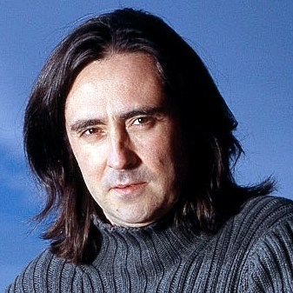
Neil is a qualified archaeologist. His fieldwork has spanned the millennia – from Stone Age remains in Scotland to Second World War fortifications. If it’s been buried in the ground during the last 10,000 years, Neil’s dug it up!
His passion for digging things up led him and his friend, Tony Pollard, to excavating battlefields from the Anglo-Zulu wars of 1879 in South Africa and their work was discovered by the BBC. This led to them doing the same thing for BBC TWO in the Two Men in a Trench series. Together they brought British battles back to life – from Bannockburn in 1314 to the Second World War.
Also a journalist, Neil has written for publications including The Guardian, The Scotsman and The Sun.
Neil, 38, lives in Glasgow with his partner Trudi and two-year-old daughter Evie, and is currently restoring his Victorian town house.

Nicholas Crane
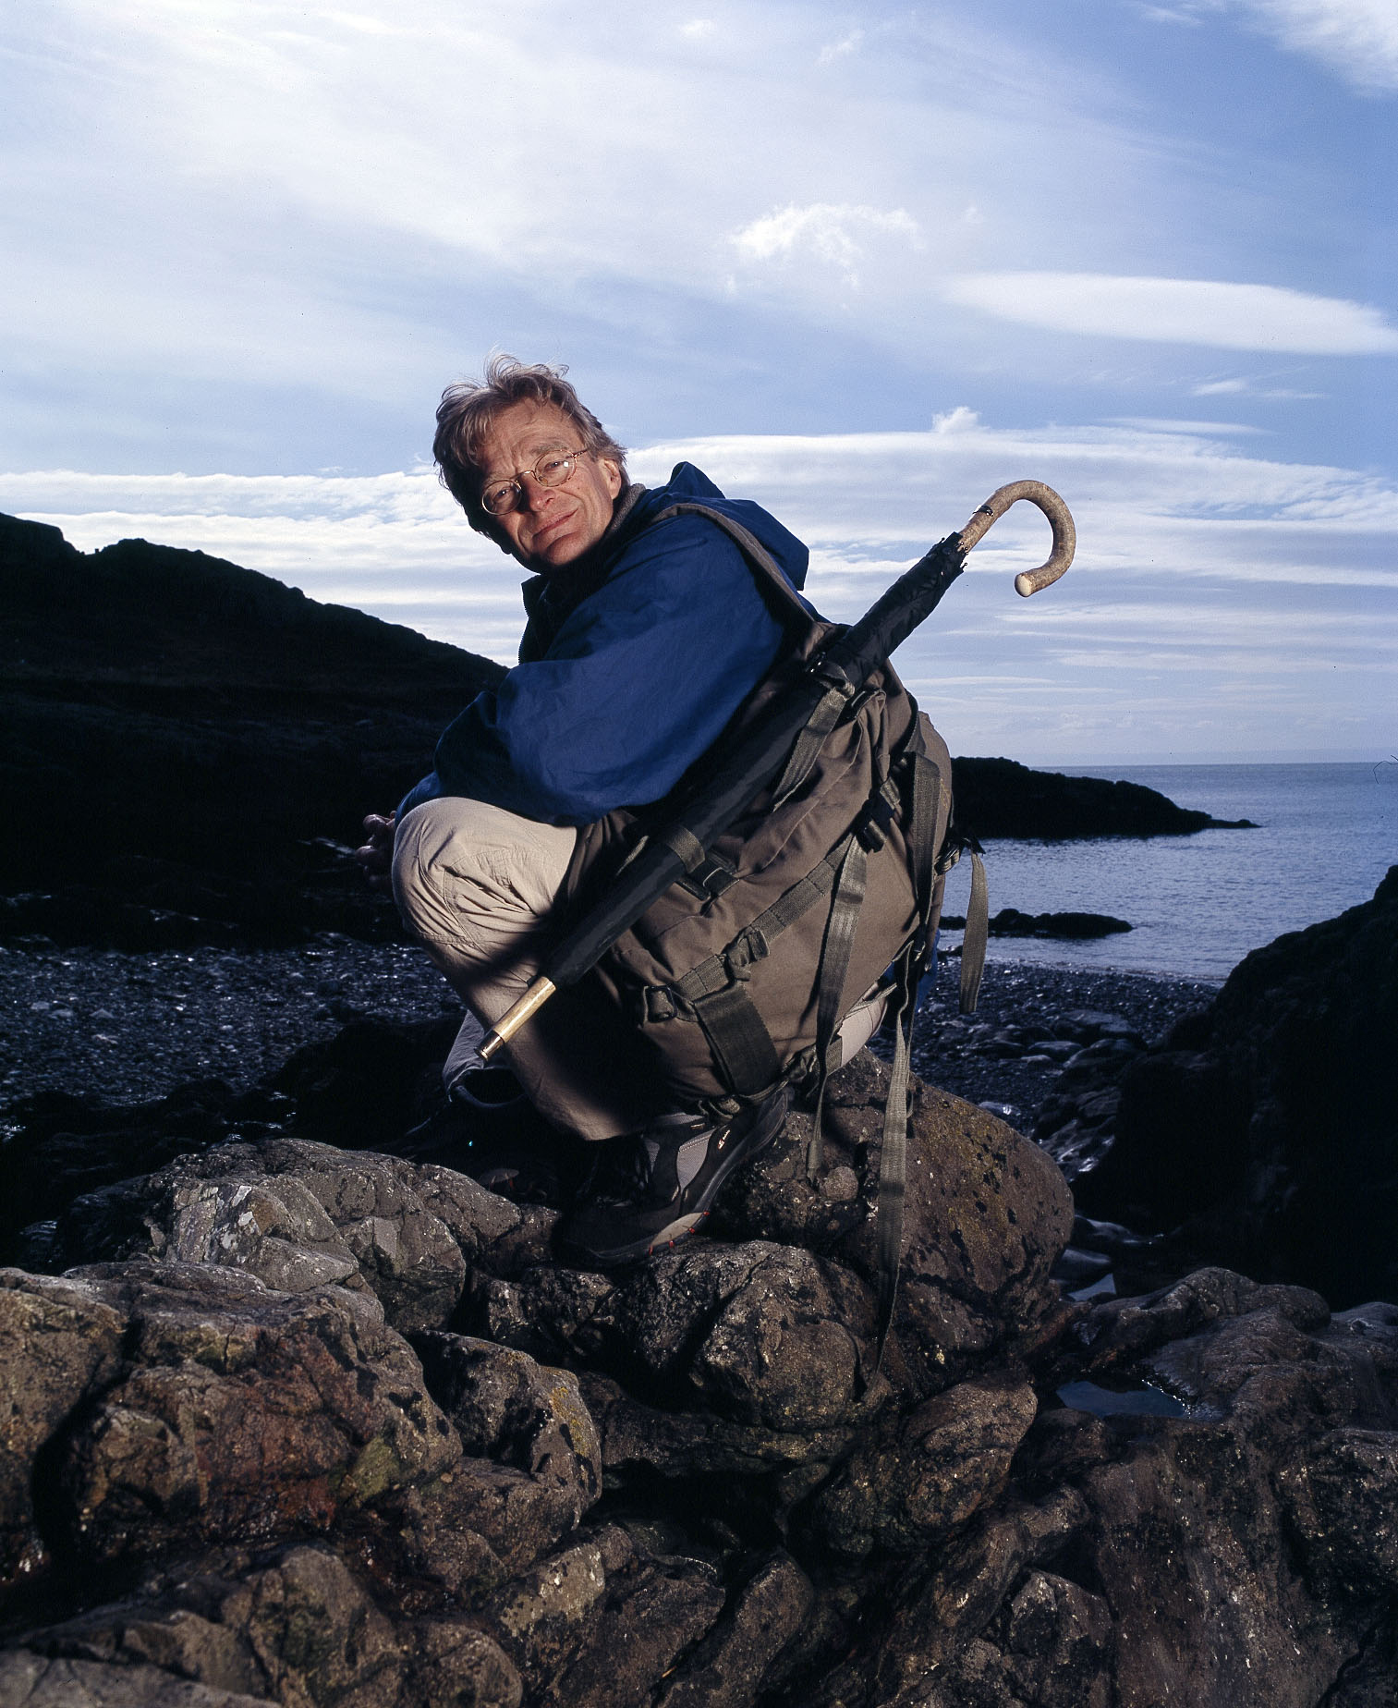
Nicholas Crane has been a full-time writer since 1979. The author of several travel books, he has also been published in the Daily Telegraph, the Sunday Times and the Guardian. In 1986 he was part of a two-man team which identified and visited for the first time the geographical Pole of Inaccessibility, the point on the globe most distant from the open sea, in a remote corner of the Gobi Desert. He has also travelled extensively in Tibet, China, Afghanistan and Africa. ‘Clear Waters Rising’, the story of his mountain walk across Europe, won the prestigious Thomas Cook/Daily Telegraph Travel Book Award in 1997. His biography of the famous 16th-century mapmaker Gerhard Mercator was published in 2002.
Nicholas's 16-part television series for BBC Two Map Man, about British cartography, was screened in 2004, and its success led to a second series, which was broadcast in the autumn of 2005. He was the lead presenter on the first series of Coast.
Nicholas is currently filming a new series for BBC TWO called Great British Journeys, and writing a book of the same name to be published alongside it.

Miranda Krestovnikoff
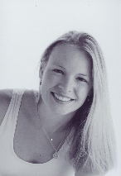
A qualified zoologist, Miranda, 32, started her television career as a researcher in the BBC’s prestigious Natural History Unit. As well as Coast, she has presented several television series, including History Mysteries and was co-presenter on The Nature of Britain, both on BBC TWO.
Her passion for wildlife started at an early age by observing birds and bugs in the garden and keeping a veritable menagerie at home. She is an experienced diver, and active outdoor girl, enjoying sailing, swimming and cycling. Miranda also writes for the Diver magazine, and makes regular appearances at dive shows and clubs.
Her other great love away from diving and wildlife is music. She plays the flute and she remains one of the founder members of the New Bristol Sinfonia. She lives with her husband just outside Bristol.
Miranda says: “My favourite coastal location from filming series 3 has to be the Guliot caves in Sark. These gems are something I might explore as a diver - rocks encrusted in jewel anemones of all different colours - but on a few rare days a year when the tides are exceptionally low, you can - with great difficulty - access these sunken treasures for a few precious hours. I went with an elderly scientist who has been visiting them for the last 50 years or so and we were accompanied by a four-strong team of local firemen - such was the difficulty of accessing the caves. It took a few hours to make our decent down a sheer cliff and across the rocks and we only had a short hour in which to film. It was like being inside a sweet shop - the walls were dripping with brightly coloured anemones with barely an inch of exposed rock. A truly memorable experience.
“I have some really great memories of filming last year - perhaps the most fun, but slightly fraught, trip was one to Roaring Water Bay near Skibbereen in Southern Ireland. I had barely 24 hours there in which to film a multi-faceted story about the local community who have begun to harvest seaweed. Due to many locals leaving the area, a co-operative was started a few years ago to sustainably harvest the vast quantities of seaweed that grow on the shores there. They cook with it, use it as fertiliser, and export it to supermarkets all over the UK.
“Firstly I was to swim and record some pieces to camera in the water, and then we had a seaweed feast - a 3 course meal with all the dishes containing seaweed. We then had a trip to the shore to identify some seaweed species and then set to with some harvesting...To round the day off, I had to get into a tub of weed and hot water as it is, apparently, very relaxing and great for your skin and hair. Sadly the hot water ran out as we were filling the bath. Light was failing and the pressure was on to get the shots so I ended up sitting in a very cold bath of seaweed - not as relaxing as I might have hoped!”

Dr Alice Roberts

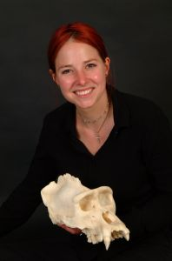
Alice, 32, is a qualified medical doctor and an expert in anatomy. She teaches anatomy at the University of Bristol and is also involved in research on human skeletal remains, both archaeological and forensic.
Archaeology is a passion for Alice, and she has been on many excavations. She is also one of the organisers of the annual Cheltenham Science Fair.
In 2001 she joined Channel 4’s Time Team after working and reporting on the bones that they had found on their digs. As well as Coast, Alice also presented Alice Roberts: Don’t Die Young earlier this year on BBC TWO.
Away from the field, Alice is a skilled artist. She also runs a weekly pub quiz at her local, and has recently discovered a passion for surfing. She lives with her partner, also an archaeologist, and dirty Border terrier called Bob!
Her favourite Coast memory is helping to build the 'Mesolithic' house in Howick, Northumberland, for the first series. She says: “I love this type of 'experiential archaeology'; it really helps you understand what people's lives were like in the past”.
Mark Horton

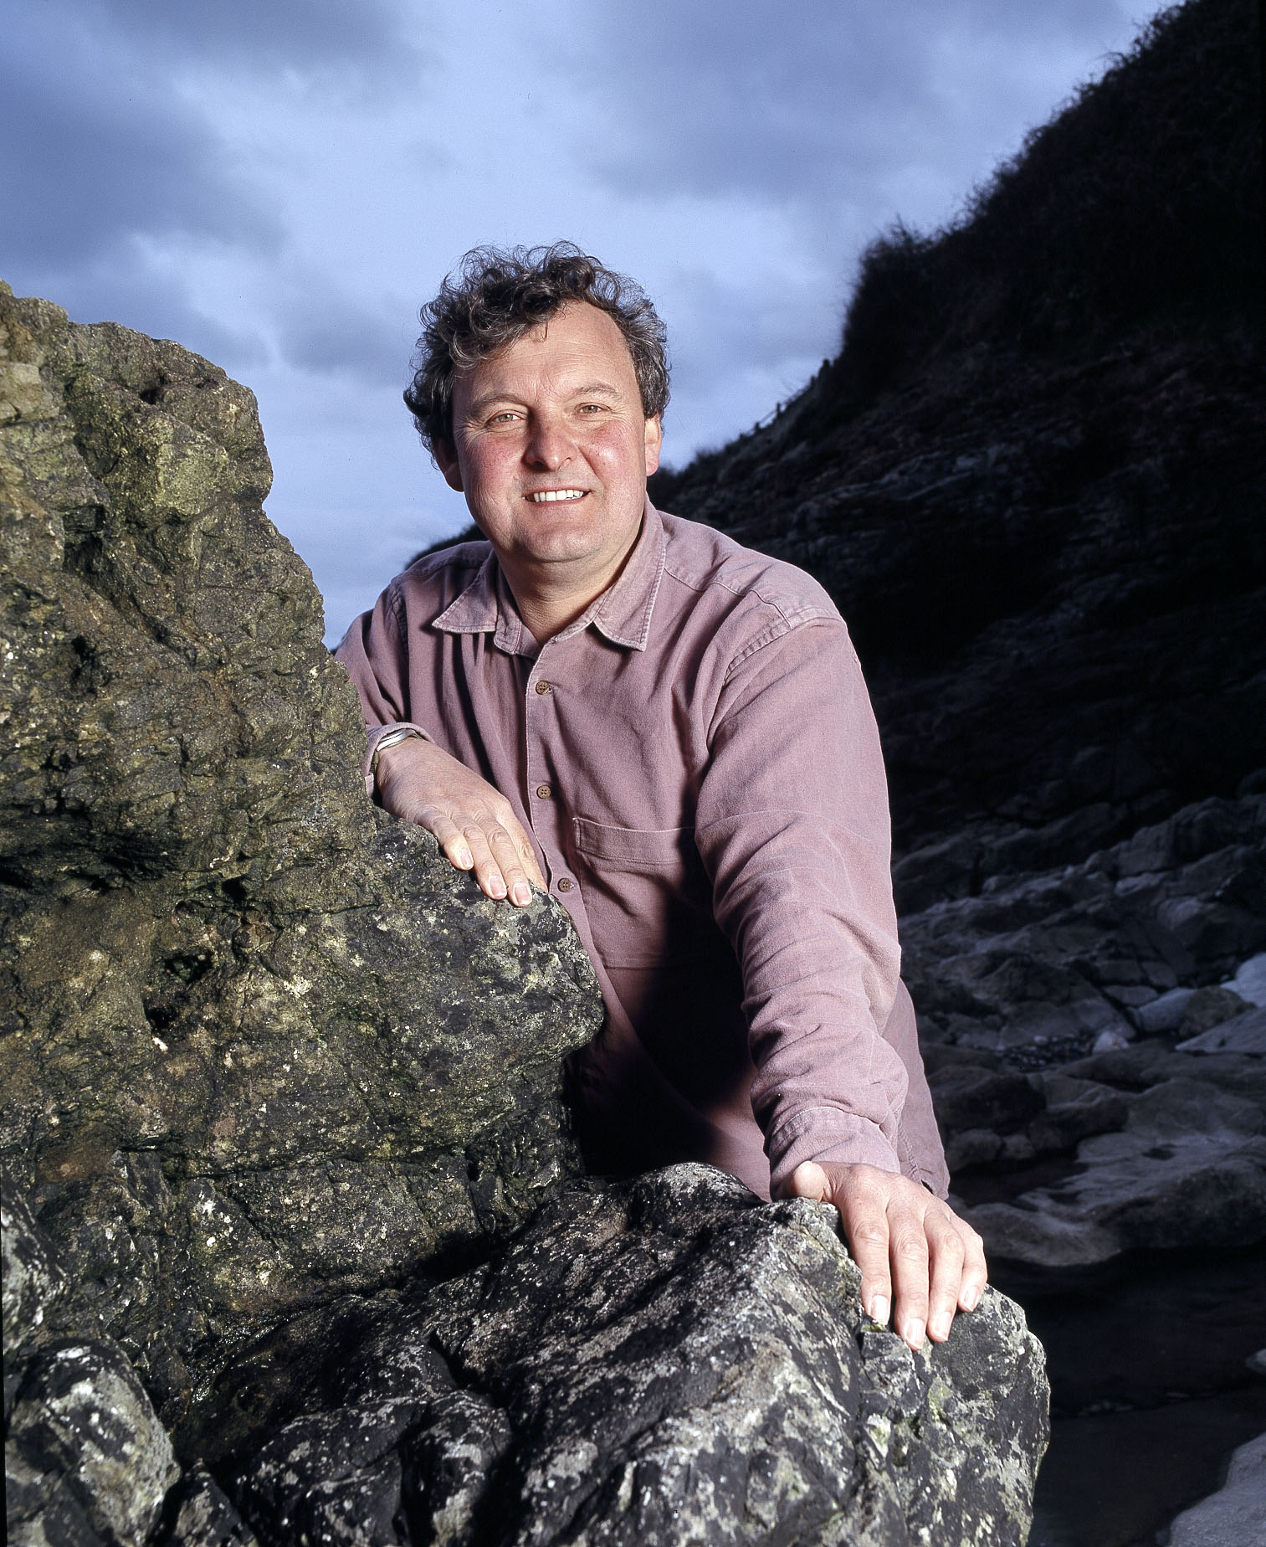
Mark is Reader in Archaeology at the University of Bristol and runs and teaches one of the few postgraduate programmes in Maritime Archaeology and History.
He has a particular interest in Maritime Archaeology and has directed excavations in many parts of the world, including the Caribbean, East Africa, Egypt and France, as well as numerous sites in Britain.
Recent projects have included an investigation of a Scottish colony in Panama, early colonial settlement on St Kitts, St Lucia, Bermuda, and the investigation of trading ports in Kenya and Tanzania. In Britain, Mark excavated the burials of claimed 'slaves' that were found on the beach at Ilfracombe in Devon, and has worked on the Port of Bristol and its trading (and slaving) connections and the industrial archaeology of Isambard Kingdom Brunel. At the moment he is writing a major study on the archaeology of Zanzibar, and this summer will be excavating the medieval town of Berkeley on the River Severn in Gloucestershire.
Mark is keen sailor, and spends his spare time either dinghy sailing on the River Severn or restoring his historic 26 - ft Maurice Griffiths - designed yacht in London. He also has a rotting dhow in Lamu, Kenya.
Mark has been a contributor to numerous TV and radio archaeology programmes, and was involved in the early days of Channel 4’s Time Team as well as the BBC Scotland Documentary on the Darien Disaster which was awarded the Archaeological Programme of the Year in 2004. Most recently he has co-presented the BBC Two series Time Flyers, which charted our history from the air.
Hermione Cockburn

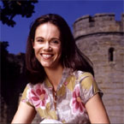

Hermione won the BBC Talent Science Presenter scheme in 2002 and hasn’t looked back presenting series such as What the Ancients did for us and Rough Science on BBC Two to Shifting Sands, The Ice Age, and Gold on Radio 4.
When not presenting TV and radio programmers, Hermione teaches Environmental Science (S216) for The Open University in Scotland and is involved in OU outreach initiatives to encourage people to study science. Her students come from many different backgrounds but share her passion for understanding how the environment works.
Her favourite piece of Coastline in the UK are the beaches of the Hebridian Islands. “They are unbeatable – white sand and clear, turquoise water set in a rugged, rocky landscape. Balephuil Bay on windswept Tiree has got to be my favourite, although Luskentyre on the west coast of Harris comes a close second. Having said that, living in Edinburgh means I’m pretty spoilt with some beautiful spots along the East Lothian coast much closer to home including Coldingham Bay where my husband proposed so that bit of coast has a special place in my heart too.”

