Media Relations Office
Communications Group
The Open University
Milton Keynes
United Kingdom
MK7 6AA
t +44 (0)1908 653343
f +44 (0)1908 652247
e Press-office@open.ac.uk
w www.open.ac.uk/media/




News

For the attention of: News Editors
Monday 7 January [PR5432]

The Open University gets Under the Skin of Life in Cold Blood on BBC ONE
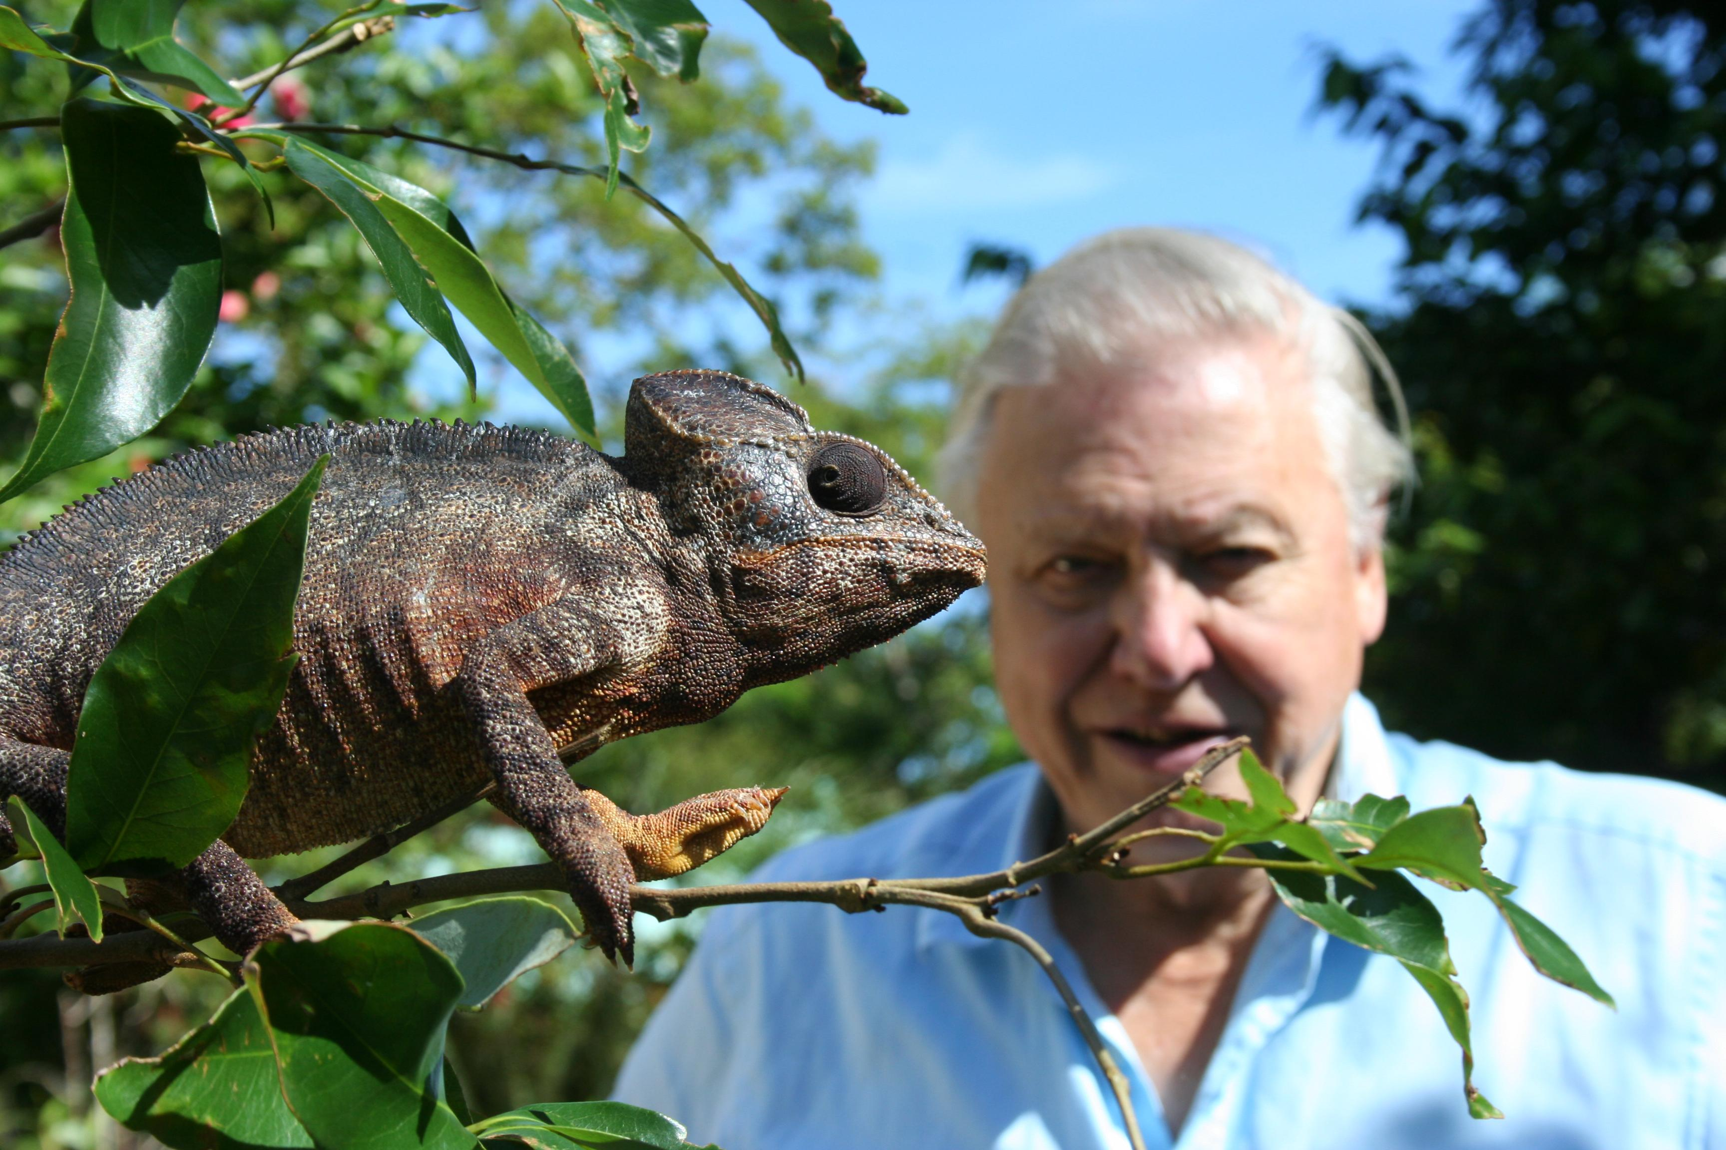
Sir David Attenborough gets up close and personal with a Madagascan Chameleon
TX: 9pm, Monday February 4, BBC ONE (repeated on Sunday February 10, 6pm, BBC ONE)
The Open University and BBC ONE present Sir David Attenborough’s final landmark nature series with ‘Life in Cold Blood’. The series features reptiles and amphibians and completes Sir David’s overview of life on planet Earth.
It is the epic story of the cold-blooded amphibians and reptiles, arguably the most successful creatures to walk on land. They dominated the world for nearly 200 million years and well over 14,000 species still flourish today, with new ones being discovered every week.
To complement the main ‘Life in Cold Blood’ series, The Open University has funded a series of five, 10 minute programmes called ‘Under the Skin’ which reveal the in-depth scientific study and breathtaking technical know-how that has gone into the making of the episode it accompanies. They will be screened immediately after the main episode of ‘Life in Cold Blood’ on BBC ONE.
‘Under the Skin’ will show how, with the help of scientists, new animal behaviour that has never been filmed before. The programme gives an extra look at these fascinating sequences and offer an emotional and intellectual insight into our existing knowledge of reptiles and the voyage of discovery that has lead us to this knowledge.
Out in the field, Sir David Attenborough works with dedicated scientists who help bring this unique behaviour to the screen.
The more science reveals about reptiles and amphibians, the more myths and misconceptions about them are dispelled.
Sir David says: “Reptiles and amphibians are sometimes thought of as slow, dim-witted and primitive. In fact, they can be lethally fast, spectacularly beautiful, surprisingly affectionate and extremely sophisticated”.
‘Under the Skin’ will reveal their secrets and how they have been uncovered.
Professor Tim Halliday of The Open University and chief academic consultant on ‘Under the Skin’ said: “It has been a great pleasure to work with the BBC team making ‘Life in Cold Blood’ and ‘Under the Skin’, and to see the wonderful film material that they have put together. Much of this reveals aspects of the behaviour of amphibians and reptiles that are new to science and which have never been filmed before.
“As a Herpetologist [a person who studies amphibians and/or reptiles] it is very exciting to have my favourite animals featured in such a high-profile television series. Because of their generally secretive habitats, these animals are often overlooked in natural history programmes, and this is not helped by the fact that many people find them repellent!
“Not only does ‘Life in Cold Blood’ give overdue prominence to these remarkable creatures, but it should also convince viewers that they are every bit as interesting and endearing as birds and mammals.
“My personal interest is in the current dramatic decline of amphibians worldwide, a process that has already led to the extinction of several remarkable species. ‘Life in Cold Blood’ shows how challenging survival and reproduction are for many amphibians and reptiles, as well as highlighting what we will lose if these fascinating animals disappear for ever.”
While the programme features reptiles and amphibians from all over the world, The Open University is on hand to encourage viewers to take an interest closer to home. A free full colour poster featuring the 14 species of reptiles and amphibians that live in the UK will be available following the first episode.
It can be obtained by calling 0870 787 4455 (local rate) or via www.open2.net

Editor’s Notes

‘Life in Cold Blood: Under The Skin’ is a fully-funded Open University production for BBC ONE.
It will be broadcast from 9pm on Monday February 4 on BBC ONE and be repeated at 6pm on Sunday February 10 also on BBC ONE..
Series Producer for the BBC is Miles Barton, Producer is James Brickell and Executive Producer for The Open University is Catherine McCarthy. The Open University Academic Adviser is Professor Tim Halliday.
The Open University and BBC have been in partnership for more than 30 years, providing educational programming to a mass audience. In recent times this partnership has evolved from late night programming for delivering courses to peak time programmes with a broad appeal to encourage wider participation in learning.
All broadcast information is correct at time of issue.
For previews, images and interview requests please contact Guy Bailey
Resources
Related Courses and programmes from the Open University:-
- Y161 Introducing Environment
- S180 Life in the Oceans: Exploring our blue planet
- S193 Fossils and the history of life
- S104 Exploring Science
- S154 Science starts here – a short course
- T172 Working with our Environment: Technology for a sustainable future
- T189 Digital Photography: Creating and sharing better images
- SXR103 Practising Science (Residential Course)
- S204 Biology – uniformity and diversity
- S216 Environmental Science
- SXR216 Environmental Science in the field (Residential Course)
Websites:
Courses: http://www.open.ac.uk/courses
Programmes: http://www.open2.net
Media Contacts
Guy Bailey g.r.bailey@open.ac.uk +(44) 1908 653248
’Under the Skin’ Series Synopsis
Programme One - Charismatic Chameleons
Monday February 4, BBC ONE, 9pm and Sunday February 10, BBC ONE, 6pm
Sir David Attenborough travels to Madagascar in search of a reptile he has been waiting nearly half a century to see. He first visited Madagascar in the 1950s filming for the series ‘Zooquest’ and was impressed by the incredible variety of chameleons he saw there. He had read of one – the Pygmy Leaf Chameleon –the world’s smallest reptile, but he never managed to see one. Now, 46 years later, he is going to get another chance.
This time though, he has the help of chameleon biologist Bertrand Razafimahatratra, and it’s a good job too - because these tiny chameleons are barely the size of a thumbnail. The technique Bertrand uses to find chameleons in the forest is based on years of experience. Despite them being active in daytime, he hunts for them in pitch black using only torch light. This is because they are paler and they stand out in the light of a torch whereas their camouflage makes them nigh-on invisible during the day. He also knows that they tend to hide at the tips of branches to escape predators like snakes. It’s a far cry from when David first tried to find them all those years ago.
With Bertrand’s help they find many different chameleons during their night-time safari: huge Oustelet's Chameleons, enigmatic Stump-tailed Chameleons and colourful Panther Chameleons. Only with Bertrand’s local knowledge, field-craft and a lot of luck, will David have any chance of fulfilling his life long ambition of finding the tiny Pygmy Leaf Chameleon.

Programme Two - Warning from the Wild
Monday February 11, BBC ONE, 9pm and Sunday February 17, BBC ONE, 6pm
The filming of the bizarre semaphoring behaviour of the Panamanian Golden frog is a race against time. The rushing water of the mountain streams and waterfalls where they live drowns out croaks and calls so they have evolved a visual method of communication. Already threatened by habitat destruction and over-collecting, a killer fungal disease is now moving towards their last remaining forest stronghold at about 40 kilometres a year, wiping out every one of these stunning looking frogs in its path. Series Producer Miles Barton cuts short his Christmas break to join the crew and frog biologist Erik Lindquist at a top-secret location in the Panamanian rainforest.
Before filming the crew have to disinfect their filming gear with bleach to prevent infection of the frogs but eventually they capture the frogs’ waving and social behaviour for the first time. When Sir David Attenborough joins them, Erik shows him how to find the frogs by calling to them and he describes how he first discovered the frogs’ unique waving behaviour back in 1994.
He goes on to explain how he and other scientists have investigated whether the Golden Frogs are indeed communicating with each other, using a variety of equipment including tiny mirrors, a plastic model frog (which Sir David uses without much success!) and even one on TV.
But there is a sad end to the story. Since the filming, the location was overtaken by the Chytrid fungus and the surviving frogs have been taken into a frog hospital to be cured of the disease. So, for now, the Golden frog has waved its last in the wild. It is possible that, in the future, suitable, disease-free natural habitat can be found into which captive-bred golden frogs can be introduced.

Programme Three - Family Affairs
Monday February 18, BBC ONE, 9pm and Sunday February 24, BBC ONE, 6pm
David Attenborough meets Mike Bull and his team who study the social lizards of South Australia. They know thousands of the reptiles individually and use all manner of gadgets and gizmos to investigate the Sleepy Lizard or “Shingleback's” secret life. The aptly named ‘waddleometer’, measures the lizard’s rate of movement, its position and even whether it is in the sun or shade – all automatically. Then there is the robo-lizard mounted on a toy truck to test how the lizards react to intruders. In the course of this work they have made new discoveries and overturned our preconceptions about “cold-blooded” animals.
Mike’s twenty year study of sleepy lizards revealed that they are faithful to each other for up to two decades and will even remain with their partner for several days if it dies.
Mikes team suspected that another lizard in the area - the Gidgee Skink - had an even more enduring family life than the Sleepy Lizard. But this was difficult to prove because when approached, they wedge themselves in cracks in the rocks making it impossible to identify who's who. Their solution was to microchip each lizard so it could then be scanned, just like supermarket shopping, with a bar-code reader on the end of a pole. This revealed that the clumps of lizards seen on rockpiles are actually close-knit families whose young stay with them until adulthood.
Now Mike is studying a lizard that was believed extinct for over 30 years - the Pygmy Blue-tongued skink. Further investigation revealed exactly why it has stayed hidden for so long - it lives in tiny trap-door spider burrows. To unlock its secret lifestyle Mike Bull and the crew join forces to record, for the first time ever, its family life – three baby Skinks in the burrow with their mother.

Programme Four - Rattlesnake Stakeout
Monday February 25, BBC ONE, 9pm and Sunday March 2, BBC ONE, 6pm
The crew travelled to New York State to film the ‘Holy Grail’ of wildlife behaviour – a rattlesnake hunting in the wild. This has seldom been seen and never before filmed, so they sought the help of world renowned expert Harry Greene. He has been studying snakes for more than forty years and has uncovered some remarkable secrets about rattlesnake behaviour, revealing them in a whole new light.
Radio telemetry technology has enabled Harry and his students to follow individual snakes for days, weeks and, in some cases their entire lives. With the help of Harry and his team, the ‘Life in Cold Blood’ team have the opportunity to find and track a wild timber rattlesnake called Hank. Using a specially constructed camera trap the team get lucky when they film him hunting at the very first attempt but then they fail to get the complete sequence with him eating. So it’s back to the drawing board as they track Hank, twenty four hours a day for two weeks. They discover it is both difficult and dangerous tracking a perfectly camouflaged venomous snake in the pitch black!
Their progress is also hampered by the worst floods that New York State has seen for years. Days of rain bring activity to a standstill, but finally Hank starts to hunt again. When he chooses an ambush site the team work fast to set up infrared lights, remote cameras and motion detectors to bug the area, meanwhile the team retreat to a filming hide to wait. To their surprise the cameras capture, a second successful hunt and this time Hank, rather obligingly, eats his meal right in front of the camera!
Programme Five - The End of an Era
Monday March 3, BBC ONE, 9pm and Sunday March 9, BBC ONE, 6pm
Sir David Attenborough goes to the Galapagos to meet the rarest reptile in the world - a giant tortoise that is the last of his kind. ‘Lonesome George’ as he is known, is a shining example of evolutionary theory in practice. Each island in the Galapagos supports a different race of tortoise; each with a different shell shape that better suits eating the food available to them. Over the years they have been hunted as food and some are now critically endangered. George is the very last individual from Pinta Island so it is likely that his race is doomed to extinction. For the other tortoises there may be some hope because scientists on the islands are working to preserve these pillars of Darwinian history. Each race is captive bred in a separate enclosure at the Charles Darwin Research Station and the hatchlings reared till they are big and strong enough to resist attack by the rats that have been introduced to the islands. Once their native islands are rat-proof, they are safely returned to their homes.
These are not the only threatened animals that the ‘Life in Cold Blood’ team came across filming the series. Habitat destruction in Japan is threatening the welfare of the 5 foot long Giant Salamanders. The Panamanian Golden frogs that David met filming for the amphibians programme are, at the time of transmission, officially extinct in the wild. Gharial Crocodiles have been on a knife edge for 30 years and are still in trouble as more and more of their habitat is destroyed. Meanwhile, Gopher tortoises are also fighting a losing real-estate battle with developers in Florida.
Lonesome George is an iconic representative of the threats that face the reptiles and amphibians; as well as a testament to the hard work of scientists working to help them. It is likely that it will all come to late to save him but as Sir David Attenborough puts it “at least he can be a living inspiration to us all to protect the remainder of the reptiles and amphibians of the world”.

