

Media Coverage Report to the Council

Media Coverage for The Open University,
June 28 to September 14

Produced by the Media Relations team, part of the University’s Communications unit
September 2006

 Executive Summary

Introduction
This report summarises the media coverage The Open University received between June 28 and September 14 2006.

The focus for the OU Media Relations team over this period has been on:
- achieving media coverage for a number of University projects and achievements, including the results of the National Student Survey 2006:
- research activity;
- media engagement for a number of high-profile OU/BBC peak-time series;
- the maintenance of an effective media relations service during a period of staff change, including the appointment of a new head of media relations and two new media relations officers.

Media relations activity and coverage analysis
During the period of this report, the OU media relations team issued 25 news releases and handled 154 media enquiries.

Over this period the team has tracked and monitored 1,196 items of news coverage that included a reference to The Open University and/or OU/BBC programmes. This figure is lower than the total for the similar period of 2005, when 1,561 items were recorded; the 2005 figure included coverage arising from the Graduate Publicity Project. For the 2006 project, these figures are detailed separately in Appendix 3.

Chart 1: Media coverage period comparison – Jun to Sept 06
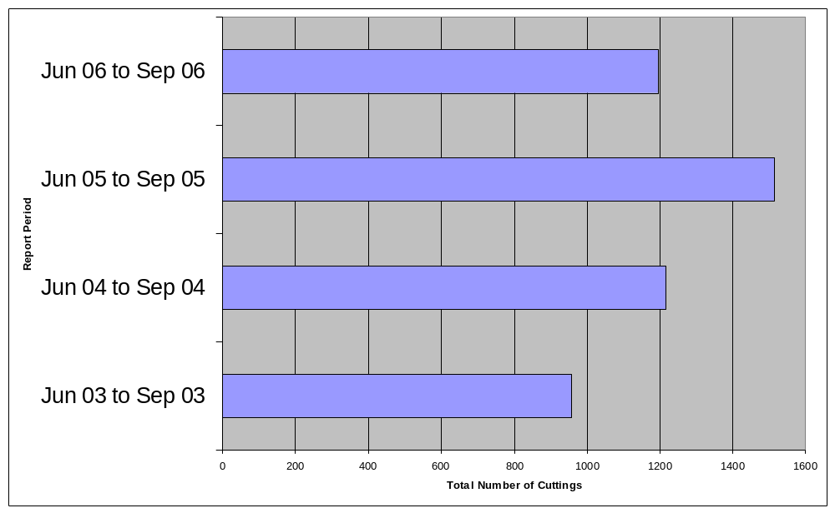
By categorising each piece of media coverage as:

- “OU Expert Comment” (news items about OU research or academic expert comment)
- “OU News” (news stories about OU initiatives, activities or developments); or
- “OU Name Check” (articles which make only a passing reference to the OU)
it has been possible to provide a basic quantitative and qualitative indication as the potential communication impact this coverage could have made. See Chart 2 below.

Chart 2: Media coverage by content – Jun 06 to Sep 06
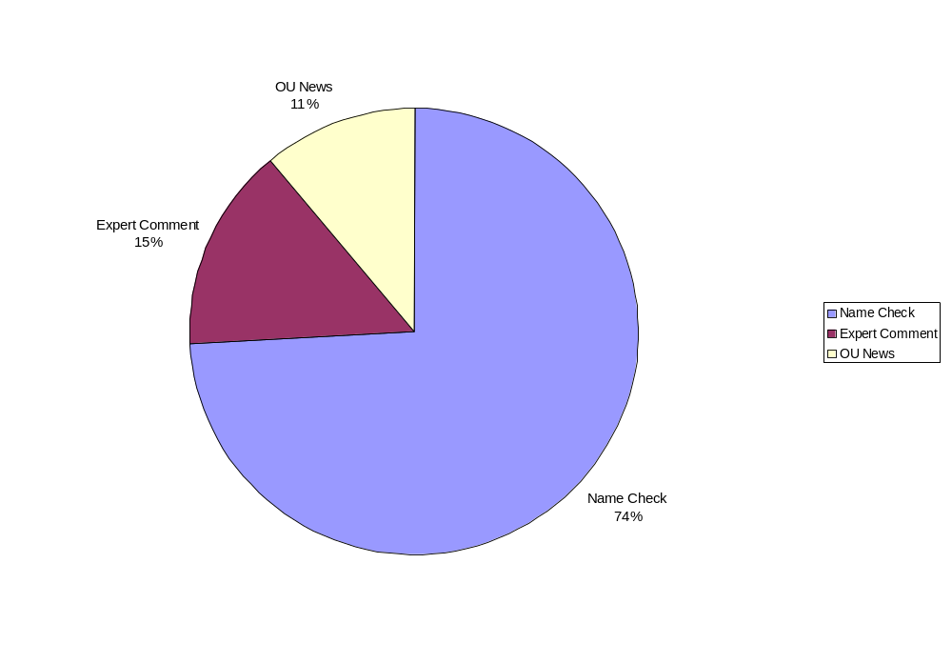Key media coverage for the University during the period included the following:

Key media issues
The University’s achievements in the National Student Survey 2006 were widely reported in national and regional media. Both The Guardian and the BBC published a rankings table of the results based on the overall satisfaction scores achieved. With an average overall satisfaction score of 4.5 out of 5, the OU was positioned at the top of these tables. Other national media – specifically The Sunday Times and the Times Higher Education Supplement – used different ranking criteria that put the University in second place.

Graduate Publicity Campaign
The OU 2006 Graduate Publicity Campaign began in April and attracted significant local, regional (and some national) media coverage of OU graduates across the UK.

During the period of this report, an additional 60 local, regional and national media articles and items were published or broadcast as a direct result of the campaign - in addition to the 151 published in the last report period.

The 2006 campaign profiled the achievements and successes of OU graduates, highlighted the diversity of OU graduates, and demonstrated how an OU degree can advance one’s career.
(The quantity and quality of the media coverage so far this year compares favourably to the 138 recorded news articles and items which were recorded as a result of last year’s Graduate Publicity Campaign). See Appendix 3 for details.

Disciplinary areas and research expertise
There was widespread media coverage of a new social sciences project headed by Marie Gillespie, senior lecturer in Sociology, which will consider British society and issues of identity through its humour. The project is linked to an OU/BBC programme on the subject called “Lenny’s Britain” hosted by OU student Lenny Henry which will be screened in 2007. The media relations team’s objective was to ensure coverage did not devalue the research and its intent and to raise public awareness of the project.

A number of research areas – including space sciences, earth sciences, and health and social care – continued to attract widespread national and specialist media coverage.

OU/BBC partnership
A total of 145 news items were monitored during the period of this report covering a number of OU/BBC programmes including The Somme: From Victory to Defeat; The Mark Steel Lectures; The Money Programme; More or Less; and The Material World.

Further specific details of the media coverage during the period of this report are included in the attached appendices.

Focus for the media relations team for the next period
Over the next two to three months the OU media relations team’s focus will include:
- Providing media relations and PR support for various student recruitment efforts and initiatives, particularly those focussing on younger students as well as communicating the financial support available to prospective OU students;
- Providing media relations support for the launch of high-profile projects, including OpenLearn;
- Offering appropriate media publicity support for selected, strategically important OU initiatives and projects (which have the potential to generate media interest); and
- Continuing to plan and deliver media training to staff in OU Regions and selected academic staff (based on needs and demand).
Appendices

Page

Appendix 1 Contentious coverage, issues and other 6
Significant mentions

2 Curriculum, learning and students 8

3 Graduate Publicity Campaign 10

4 Expert comment and research news 12

5 News from the regions 17

6 OU/BBC partnership and broadcast coverage 19

7 Media relations activity and detailed analysis 22

Contentious coverage, issues
And other significant mentions

APPENDIX 1
1.1 Contentious coverage
1.2 Other significant mentions

  - Contentious coverage and Issues
There were no articles reported in the media that could be classified as Contentious in the period covered by this report.

1.2 Other significant mentions
The University’s achievements in the National Student Survey 2006 were widely reported in national and regional media. Both The Guardian and the BBC published a rankings table of the results based on the overall satisfaction scores achieved. With an average overall satisfaction score of 4.5 out of 5, the OU was positioned at the top of these tables. Other national media – specifically The Sunday Times and the Times Higher Education Supplement – used different ranking criteria that put the University in second place.

Coverage included an article in the Education section of The Independent about the survey achievements of the University of Buckingham, whose students also rated their institution highly. The article sought to conflate the achievements of the two universities. A letter by Will Swann – Director, Students – in the following edition sought to differentiate the achievements and strategies of the two universities.

Ongoing coverage about the growth on online provision in the sector included several references to the OU’s work in this area. The consistent message from the OU is the use of online learning resources as part of a wider learning experience.

Two OU colleagues – Dr Robert Lambourne, of the Faculty of Science, and Gill Needham, of the Library - were among 50 from the sector who were presented with National Teaching fellowships; coverage included articles in the Times Higher Education Supplement.

Several national media published obituaries for Naomi Sargant, pro-vice-chancellor for student affairs from 1974 to 1978. She went on to be professor of applied social research until 1981, when she left the University to move into broadcasting.

The increasing number of younger students at the University continues to attract coverage, which has included a general article and case study material in the London Evening Standard.

Widespread media coverage for the research section of a new social sciences project that will consider British society through its humour was achieved. The project is linked to an OU/BBC programme on the subject to be screened in 2007. The media relations team’s objective was to ensure coverage did not devalue the research and its intent.

Publication of the University’s monthly pages in The Independent (on the first Tuesday of the month) continued. Feature subjects included the development of the psychological study of happiness, and OU graduate and musician Paul Tkachenko, an example of the growing number of younger students.

Curriculum, learning and students

APPENDIX 2
OU’s strategic priorities:
- Promote fair access to all
- Create market responsive innovative offerings
- Strengthen leadership in modern pedagogy

2.1 Life-long learning
2.2 Students and graduates

2.1 Life-long learning
Coverage about general Open University study included:
- The Times reported about a HEFCE study on widening participation and noted that “The Open University has operated, quite successfully, an open-access scheme without standards being compromised.”
- The Daily Telegraph reported on an idea by education secretary Alan Johnson to allow students to study part-time and over the internet. The story says The Open University would be a potential model.
- Times Higher Education Supplement featured a story on academics that love teaching but want freedom to pursue other interests are turning to The Open University.
- Prima Magazine in its “5 new things to learn” section detailed The Open University as the place to get a degree, listing a contact number and website.
- The Glasgow Herald bemoaned the loss of OU summer schools saying they would be missed and that summer school weeks “have been the stuff of legend and not a little mythology.”
- Scottish Daily Express angled an OU story on the number of younger students enrolling.
- South Wales Echo reported that one out of every five new undergraduates at the OU aged 24 or under.
- Lancashire Evening Post featured the young student angle under a headline: “Open University isn’t just for grown-ups”.
- Lighter Life magazine featured two OU students who had nothing but praise for their courses and support they received.

Coverage of specific courses and programmes included:
- Transit magazine reported on a partnership with the OU and First buses plus the Chartered Institute of Logistics and Transport to launch a new professional development programme for managers and graduates.
- Irish News Belfast said falling primary school rolls mean the OU and others have had to cut teacher training places in Northern Ireland.
- Nursery World reports that the OU Early Years Professional training programme filled 95 of its 100 places while others struggle to reach double figures.
- Cambrian News reports two innovative free courses led by The Open University in Wales are popular. They both involve teachers who want to change careers to teach vital courses.
- Times Educational Supplement Scotland reported on a new formula for tackling the national shortage of maths teachers allowing mature students a chance at an OU course Maths PGCE. Ayr Advertiser reported on a woman taking that first-ever course.
- Local Transport Today says Transport for London has partnered with the OU to offer a diploma in travel planning, launching in October.
- Plymouth Evening Herald says the Open University Validation Services has agreed to validate arts courses from the Plymouth College of Art and Design.
- Wokingham Times and Bracknell &Ascot Times report teaching assistants completed their specialist teaching assistant certificates through a course the OU designed for Wokingham District Council.
- Birmingham Evening Mail details the OU Post Graduate Certificate of Education course in shortage subjects.
- Third Sector had details of a scholarship scheme from the Institute of Fundraisers and the OU for Winning Resources and Support courses.

2.2 Students and graduates
Among the graduates and alumni whose OU studies were referred to in national press articles were:
● Fiona Owen and Professor Effie Maclellan were featured in a profile of students who have benefited from OU study experience in Lighter Life magazine.

● Comedian Lenny Henry, whose current TV projects include a new situation comedy based on his experiences as an OU student.

Graduate Publicity Campaign

APPENDIX 3

OU’s strategic priorities:
- Promote fair access to all
- Create market responsive innovative offerings
- Strengthen leadership in modern pedagogy

3.1 Introduction
3.2 Graduate Publicity Campaign 2006 results
3.3 Examples of graduate publicity

3.1 Introduction
An ongoing core strategic aim of the university's Media Relations team is to highlight the success and diversity of OU graduates and support student recruitment efforts.

This year more than 11,000 new graduates qualified for undergraduate and postgraduate degrees. At degree ceremonies graduates were joined by people from the world of arts, journalism, academia and business who received honorary degrees in 26 ceremonies across the United Kingdom.

The national media and in particular regional media take advantage of these graduate case studies as often they illustrate stories of triumph over adversity, dramatic life changes or career success, and for the regional media the added bonus of the graduate living in their circulation area/among their audience.

3.2 Graduate Publicity Campaign 2006 results
The campaign began in March and concluded in September. To date 211 local media articles and items were published as a direct result of the Graduate Publicity Exercise 2006. This is more than the 138 recorded for the Graduate Publicity Campaign in 2005.

Area | Apr - Jun | Jun - Sep | Total
The Open University in London | 9 | 2 | 11
The Open University in the South | 20 | 4 | 24
The Open University in the South-West | 21 | 2 | 23
The Open University in the West Midlands | 1 | 14 | 15
The Open University in the East Midlands | 6 | 1 | 7
The Open University in the East of England | 15 | 7 | 22
The Open University in Yorkshire | 27 | 1 | 28
The Open University in the North-West | 6 | 11 | 17
The Open University in the North | 5 | 3 | 8
The Open University in Wales | 4 | 1 | 5
The Open University in Scotland | 4 | 6 | 10
The Open University in Ireland | 7 | 4 | 11
The Open University in the South- East | 26 | 4 | 30
TOTAL | 151 | 60 | 211

3.3 Examples of graduate publicity
- There were large, double page features on OU graduates in the Colchester Evening Gazette, the County Down Spectator, the Burton Mail and the Portsmouth News.
- There were also full page feature stories in the Ipswich Evening Star, The Hartlepool Mail, The Cambridge Evening News, The East Kent Mercury, The Halifax Evening Courier, The Tamworth Herald; Kentish Express, The Slough and Langley Observer, The Basingstoke and North Hants Gazette, The South Wales Echo, The Dorset Echo,; The Newtowarnards Chronicle, The Belfast Telegraph, The Hull Daily Mail, The Swindon Evening Advertiser, The Stoke Sentinel, The Norwich Evening News,; The Thetford and Watton Times and The Sheffield Star; and City AM;
- There were also lead editorials in The Slough and Langley Observer and the Windsor, Ascot and Maidenhead Observer praising the OU and the hard work of its students.
- Bill Callinder-Scott, from Islington, London, was featured in the Sunday People after completing his Mathematics degree, 30 years after he last studied.
- Mal Morris was featured in the Wrexham Mail with his degree in Health and Social Care. Mal is also the mascot for two local hospices and dedicated his studies to the memory of his sister Pam. He is also the OUSA treasurer in Wales.
- Uma Rana, a mother of two from Bradford, appeared in the Bradford Telegraph and Argus and the Eastern Eye after she left school without any qualifications and gained a Social Science degree.
- Kathleen Myers, 81, from York achieved her mathematics degree after seven years of study but as the York Star reported, “You’re never too old to learn”.
- Joan Hodgson, 80, from Hertfordshire was pictured in the Hertfordshire Mercury receiving her degree in English Literature and Art History from Baroness Boothroyd.
- Jerzy Lando, 83, from Highgate, London survived the Holocaust; he has completed a degree in European History. He was pictured in the Hampstead and Highgate Express and the Islington Gazette.
- Mother and son Lynn and Darren Brand, from Hailsham, Sussex, both gained degrees at the same ceremony. Lynn received a BSc (Hons) in Social Policy and Darren a BA (Hons). They were pictured in the Brighton Argus.
- The Dorset Echo reported that Daniella Reed from Dorset spent five years studying with the OU after being diagnosed with severe dyslexia.
- Musician and circus performer Paul Tkachenko was featured in the Walthamstow Guardian in an unusual photograph where he was pictured playing 10 instruments! Paul gained an MA in music.
- Trai Anfield, BBC weather presenter and OU graduate, was profiled in The Northern Echo and the Journal.

The Graduate Publicity Campaign website with all the information about this year’s graduates and degree ceremonies is at http://www.open.ac.uk/graduation2006.
Expert comment and research news

APPENDIX 4
OU Strategic priorities
- Focus research activity
- Work in partnership

A number of academic experts and research-based stories from the OU during this period generated widespread media coverage.

Social Sciences
Marie Gillespie had numerous quotes in the media with the launch of a survey of humour in the UK. Her objective is to decipher the social and political climate and find out what makes us laugh. The research will feature in an OU/BBC One programme called “Lenny’s Britain” which features Lenny Henry travelling the country, meeting ordinary people and trying to make sense of modern British Identity through humour.
– Sun, Daily Star. Times leader, Independent column, Broadcast, BBC Radio 5 Live, Asian Network, BBC Radio Kent and 10 other regions, Yorkshire Post, Birmingham Post, Blackpool Gazette, Exeter Express, Glasgow Evening Times, Newcastle Evening Chronicle, Lewisham News Shopper Greenwich & Blackheath News, Bromley News New Nation, Bexley News, Munster Express, Dartford Times, Gravesend Reporter, Kent on Sunday, Dudley Chronicle,

Peter Smith, a global political analyst from the OU in the North, commented on the Israeli invasion of Lebanon for a feature story.
  - Northern Echo
Marie Gillespie was interviewed as an expert on public perceptions of terrorists.
–BBC Radio Berkshire
An article on financial education in the face of rising personal debt quoted George Callahan of the OU faculty of social sciences as being in favour of more specialised education.
– The Scotsman

Sociologists want more regulation of cosmetic surgery industry. Social Sciences Professor Margaret Wetherall commented on research into people images currently going on.
– Times Higher Education Supplement

Visiting research fellow Dr James Whitfield’s pamphlet on police strategies for training police in multi-ethnic areas was the basis of a feature article.
– New Start

Science
Features on The Open University-led project Darwin which hopes to get a part of £450 million in European Space Agency research funds. Professor of Astronomy Glenn White is quoted.
– Independent, BBC Focus

A new Mars rover vehicle named Bridget is to be part of a European Space Agency mission in five years. Coverage includes mention of Prof Colin Pillinger and the Beagle 2 mission.
– Yorkshire Post, the Guardian, Independent, Focus, MK News

Prof Charles Cockell comments on humans in space--what life would be like for human astronauts on Mars.
–BBC Radio 4 Biological Pressures

Dr Andrew Ball (PSSRI) took part in an interview on lunar exploration with Nick Davidson
–BBC Science Dept. for Horizon.

The Open University is a partner in an Oxford hospital facility to research brain function giving clues to helping those with autism and reading disorders.
– Nottingham Evening Post

Professor John Zarnecki commented on an ESA/NASA space mission to map the Sun.
- The Guardian
Professor Zarnecki was quoted in an article on the ESA moon mission and the need for future missions to the moon.
-The Guardian
Mahesh Anand and Andrew Ball both contributed quotes about the wisdom and need for space travel to a feature article.
- Daily Telegraph

Professor Colin Pillinger commented on a new Hollywood film that theorises Beagle 2 was attacked by the Transformers (to be released in theatres July 2007).
– Leicester Mercury, MK Citizen

Professor Monica Grady commented on the idea of capturing a small asteroid to sling back at a larger one headed for a collision with Earth.
– The Guardian

Prof Zarnecki, Head of CEPSAR spoke about the Cassini-Huygens mission.
–BBC Radio 4 Material World

Steven Rose, Emeritus Professor of Biology, is quoted in a feature story on using fish oil supplements to boost brain power for children.
– The Guardian

Professor John Zarnecki contributed to an article about science inspiration.
–Daily Telegraph

Prof Zarnecki was interviewed on plans to map the Sun and why it's important.
- BBC Radio Solent

Astronomy Prof Glenn White spoke about the OU’s bid for part of £450 million funding from the European Space Agency for space projects.
– BBC Radio 5 Live

Science could be the key to making good business decisions was a topic by Peter Naish at the BA Festival of Science in Norfolk.
– Norwich Evening News

Brainy teenagers won a trip to meet NASA astronauts in a competition judged by Prof Colin Pillinger.
–Weston and Worle News
Tim Halliday initiated the move of 50 of the world’s leading conservation experts to call for an urgent rescue mission to save amphibians from extinction.
- Guardian

Dr David Knight, director of the OU in the North, wrote a feature article on taking care of the environment mentioning the OU connection to the BBC Climate Chaos Season programmes.
– South Shields Gazette

OU Business School
A Lloyds TSB/Open University survey found that Britain’s small firms are slow to take on new technology – a study that was reported in 38 publications from The Times to Contract Floors Magazine.

The Small Enterprise Research Team at the OU report that a third of the UK’s small businesses are exporters.
– FT, Oxford Times Western Morning News

Law Programme
Various expert comments from Professor Gary Slapper on legal issues were publicised in a continuing column on case law.
–The Times

Health and Social Care
Looking at a photo album can make us happy according to OU research.
- Scottish Daily Record, Limerick Independent, The Weekly News, Daily Mirror

Duncan Banks was interviewed about the malnutrition of elderly in hospitals.
- BBC 3 Counties Radio

The Open University evaluated material for a pilot scheme to educate school children on health issues without being patronising.
–The Guardian

The OU is involved in creating a support system for overseas nurses to avoid discrimination.
–Nursing Standard
Technology
Offshore wind farms could be a serious alternative to fossil fuels story quotes the OU’s Energy and Environmental Research Unit.
- Independent

Petros Leromonachou of the OU wrote a feature article on toll roads for an industry publication.
–Traffic Engineering & Control

Professor of Transport strategy, Steven Potter was interviewed at the beginning of London car show about the connection with global warming.
– BBC Radio 5 Live

Prof Stephen Potter took part in a panel discussion about transport strategy and alternative energy sources for cars.
– BBC Radio 5 Live

The Open University is a partner in Sparc, a network for knowledge-based, technology-led businesses to get ideas to market.
– Business Weekly

Dr Stephen Peake commented on science predicting that average temperatures will shift up 3 -5 degrees in 200 years.
–BBC 3 Counties radio

Dr Ben Lane of the OU contributed to the Low Carbon Road Transport Challenge with a proposal for a pay-as-you-drive taxation scheme based on vehicle emissions.
- Fleet News

Dr James Warren contributed expert comment on the Icelandic energy equation.
–Motor Industry Magazine

Lecturer in renewable energy at the OU Bob Everett disputes the findings of a report that ‘misrepresented’ the benefits of atomic power.
– The Observer

Dr Stephen Peake is quoted in a story about lightning striking a house.
–MK Citizen

Jim Frederickson, an environmental scientist at the OU is quoted in an article on the benefits of earthworms as recyclers.
- The Times

Maths and Computing
Professor of Computing Anne De Roeck guided readers through an issue of an IT magazine.
- Computer Weekly

Institute of Educational Technology
A research committee exploring the benefits of learning technology met at the OU.
– E.learning Age

Education and Language Studies
Steve Hurd led research in 6,000 schools which shows that buying books has more effect on English, math and science test results of 11 years olds than money spent on IT technology or teachers.
–Daily Telegraph, the Guardian

Other
Pro-Vice Chancellor Professor David Vincent argued that to make poverty history, development must include higher education.
- The Independent

In a story on science going out of fashion, the reporter quotes the fact that OU has a 48% increase in those studying science. Peter Morrod, a science tutor in Edinburgh says it’s because OU courses are more flexible and accessible.
- Glasgow Herald

Academics based at the OU are developing an idea for future education called schome, neither school nor home.
– Juno

Kevin McConway, Maths was interviewed for a feature on the National Lottery.
–BBC One Real Story

An OU student had his research on water usage in West Sussex published in the local paper. It indicated that more than 75% of people do not trust water companies to manage sustainability of water systems. The Beyond Google course team wrote a letter to a magazine on developing information skills.
– Library and Information Update

Will Swann, director, student at the OU wrote of the need for universities to be flexible to increase participation in higher education.
- The Independent

Those in part-time high education are 43% of undergraduate population, but over-looked by policy-makers. Martin Watkinson, director of planning is quoted in the story.
- The Independent.

Head of Business Service Mary Hunt was interviewed on how the OU adopted a partnership approach in building its new library.
- Library & Information Update

Professor Glenn White was quoted in a story on the relegation of Pluto from planet status as being an “Astrologist from the Open University.”
– MK News

Pro-Vice Chancellor Dr Paul Clark was interviewed as part of a story on changing ways of study at university.
– BBC Look East

Craig Storey’s research on dating geological events was published in a European journal.
–Spectroscopy Europe

An Open University study into the decline of retail markets in the UK was mentioned in a story.
–Lancashire Evening Post

News from the Regions

APPENDIX 5

The OU achieved a significant amount of media coverage, 427 stories in all, within the local and regional media (including press and radio) during the period of this report.

Most of the coverage featured stories and news items about OU graduates (as a result of the 2006 Graduate Publicity Campaign – see Appendix 3).

Other coverage comprised a combination of simple name checks (where the OU was briefly referred to), stories about OU students, alumni and courses, supplemented by region-specific stories or regional initiatives and projects.

Selected examples included:

Region 01 – The Open University in London
Dionne Gallimore, a mother of three from Wembley, won the Brian Pryor Cup for successfully completing a certificate in Health and Social Care while raising her children and working part-time (The Wembley Observer).

The OU and Haringey Council joined forces to offer a free six-month course to boost skills in Tottenham (Tottenham & Wood Green Independent)

Region 02 – The Open University in the South
14 members of OU staff volunteered to paint an adventure playground at Eaton Mill Primary School as part of the Active Community Programme (Milton Keynes Citizen)

Classroom assistants from Slough, Windsor and South Bucks achieved Specialist Teaching Assistant Certificates from the OU (Slough and Langley Observer)

Region 03 – The Open University in the South West
Baroness Boothroyd opened one of HMS Raleigh’s new apprentice classrooms in Torpoint in August. The Baroness also took the salute during the afternoon’s passing-out parade when 44 trainees celebrated the successful completion of their initial training course (Plymouth Evening Herald)

Region 04 – The Open University in the West Midlands
The Open University, which has more than 12,000 students in the West Midlands, is to sponsor the 2006 Birmingham Artsfest, the country’s biggest free entertainment festival which runs from September 8th-12 (Wolverhampton Express & Star)

50 youngsters made and raced remote-controlled Mars Rovers at Stratford’s Three Mills Island for the Open University’s Rough Science workshops which encouraged them to make small vehicles using lemons and potatoes to power them (Stratford Recorder)

Region 05 – The Open University in the East Midlands
Lisa Cave, studying for a Certificate in Early Years Practice with the OU won 1st prize of £1000 with Nursery World magazine and had her work published for her essay on “helping children to be healthy“

Region 06 – The Open University in the East of England
Dr Sally Aisbitt, lecturer in Accounting with the OU Business School died at Priscilla Bacon Lodge Hospice in Norwich aged 43. A service of thanksgiving was conducted by the Bishop of Thetford at St Mary’s Church, Attleborough, Norfolk attended by more than 300 relatives, friends and colleagues. She is survived by her husband, the Rev Michael Aisbitt, and her parents (Darlington and Stockton Times)

Region 07 – The Open University in Yorkshire
A group of six North Yorkshire poets have published their first book after being funded by the OU as part of the “Open Letter” scheme. “Bilberry Pie and other tasty tales!” is published by the Egton Bridge Writers Group (Yorkshire Evening Post)

Region 08 – The Open University in the North West
Wendy Moss, student and member of the Open University Students Association, Macclesfield branch, gained a BA in Science. (Macclesfield Express)

Region 9 - The Open University in the North
The OU is operating a drop-in advisory service at the Middlesbrough Learning Shop to help present and potential students (The Northern Echo)

Region 11 – The Open University in Scotland
OU Environmental Sciences student Antony Berretti from Newton Stewart has become the first person to drive across Europe in a van fuelled by vegetable oil. He obtained his fuel for free by asking restaurants he passed en route to give him their waste oil. (The Independent)

Dr Kenneth Jones will swap life in Athelstaneford for a three-week lecture tour of South Africa at the International Sociological Association World Congress of Sociology in Durban. His trip is sponsored by the Open University Staff Development Fund (East Lothian Courier)

International Windsurfer Ruth Elliott, 28, spent seven years studying for a biology degree with the OU and plans to do her masters. “I’ve studied in the back of a van, on planes and by candlelight”. (Scotland on Sunday)

Region 12 – The Open University in Ireland
UNISON in Fermanagh are offering members free courses with the OU to gain further qualifications and training (Fermanagh News)

Region 13 – The Open University in the South East
Mandy Leeman from Rayleigh used the Open University to drive on her career after she successfully graduated with a Diploma of Higher Education in Social Work.

OU/BBC partnership and
Broadcast coverage

APPENDIX 6

OU’s strategic priorities:
- Work in partnership

6.1 Coverage for OU/BBC programmes
6.2 Other programme coverage

6.1 Coverage for OU/BBC programmes
OU/BBC programmes that aired during the period of this report and attracted media coverage included The Somme: from Defeat to Victory; the Money Programme; the Material World; More or Less and The Mark Steel Lectures.

The Somme: From Defeat to Victory
The following statistics for press and broadcast coverage have been recorded for The Somme: From Defeat to Victory:

TV listings magazines previews and features | 11
National press previews and reviews (TV/radio supplements and daily TV/radio pages) | 31
National press articles (non-TV/radio sections) | 2
Regional press previews and reviews (TV supplements and daily TV pages) | 57
Regional press articles (non-TV/radio section) | 1
Specialist titles (e.g. history magazines)
Broadcast features
Other (web etc)
TOTAL | 102

NOTE: There were no recorded mentions of the OU in this coverage.

Quotes from the media:
“The re-enactment side of the programme was superb” Daily Mail

“I expected another well-made and affecting drama documentary telling a familiar story. In the end, however, it proved more interesting – and perhaps braver – than that.” The Daily Telegraph

“No programme about The Somme can be uplifting, but this was doing its damnedest.” Independent on Sunday

The Money Programme
The following statistics for press and broadcast coverage have been recorded for The Money Programme

TV listings magazines previews and features
National press previews and reviews (TV/radio supplements and daily TV/radio pages) | 2
National press articles (non-TV/radio sections)
Regional press previews and reviews (TV supplements and daily TV pages)
Regional press articles (non-TV/radio section) | 1
Specialist titles (e.g. history magazines)
Broadcast features
Other (web etc)
TOTAL | 3

NOTE: There were no recorded mentions of the OU in this coverage.

Quotes from the media:
“Who should make money out of the law? The Money Programme investigates a more than usually two-pronged issue tonight – are private companies and councils putting profits before a sensible approach to parking?” The Daily Telegraph

The Material World
The following statistics for press and broadcast coverage have been recorded for The Material World:

TV listings magazines previews and features | 1
National press previews and reviews (TV/radio supplements and daily TV/radio pages) | 2
National press articles (non-TV/radio sections)
Regional press previews and reviews (TV supplements and daily TV pages)
Regional press articles (non-TV/radio section)
Specialist titles (e.g. history magazines)
Broadcast features
Other (web etc)
TOTAL | 3

NOTE: There were two recorded mentions of the OU in this coverage.

Quotes from the media:
“If there’s anyone who can instil enthusiasm for an Open University science summer school, it’s Quentin Cooper” BBC Focus Magazine
The Mark Steel Lectures
The following statistics for press and broadcast coverage have been recorded for The Mark Steel Lectures:

TV listings magazines previews and features | 2
National press previews and reviews (TV/radio supplements and daily TV/radio pages) | 4
National press articles (non-TV/radio sections)
Regional press previews and reviews (TV supplements and daily TV pages) | 1
Regional press articles (non-TV/radio section) | 2
Specialist titles (e.g. history magazines)
Broadcast features
Other (web etc)
TOTAL | 9

NOTE: There was one recorded mention of the OU in this coverage.

Quotes from the media:
“Mark Steel’s series have been well-received on BBC Four; the approach is simple as he provides a humorous critical biopic of a famous person while travelling to key locations in the subject’s life.” The Times

“Open University programmes aren’t what they used to be. Thankfully.” The Scotsman

6.2 Other programme coverage
During the period covered by this report there was also follow up and residual media coverage for other OU/BBC programmes broadcast earlier this year. They included Coast; Timewatch; Springwatch; Sport Relief; Climate Chaos Night; What the Ancients did for us; Child of our Time and The Reith Lectures.

Media relations activity and analysis

APPENDIX 7

7.1 OU News releases
7.2 Media inquires
7.3 Media Relations activity: key statistics and analysis
7.4 OU Media Relations Office

7.1 OU News releases
The Media Relations team issued 25 news releases during the period of this report on a range of subjects including:

- The Open University retained top ranking for Student Satisfaction in the National Student Survey.
- The launch of the new "You and Your Money": Personal Finance in Context course to address issues of personal finance.
- The AKARI Infra-red Space Telescope showed spectacular new images of star formation and the final stages of the death of stars in our galaxy. The Open University supplied the software that translates the data.
- Research from the Small Business Research Team at the OU Business School indicated that many small British businesses were slow to embrace the benefits of new technology.

Copies of all news releases issued by the Media Relations team can be downloaded at www.open.ac.uk/media/

7.2 Media enquiries
154 media enquiries were received by the OU Media Relations Office during the period of this report (more than for the equivalent period in 2005). The inquiries were broken down as follows:

Type of Media | No. of Enquiries
National ‘quality’ papers | 21
Other National papers | 5
TES/THES | 3
Local and Regional papers | 22
Magazines (general interest, specialist and trade) | 31
Radio | 36
Television | 20
Others (incl. web) | 16
Total | 154

7.3 Media Relations activity: key statistics and detailed analysis
By classifying each item of OU news coverage as either Expert Comment from the OU, OU News or an OU Name Check, it has been possible to provide a basic qualitative and quantitative indication as to potential impact of the media coverage over this period.

- Expert Comment represents media coverage in which the OU (either as an organisation or through individual academic staff) is seen as either providing expert comment on a newsworthy issue, or leading the debate on a particular subject – such as through announcing the findings of research conducted at the OU. Media coverage of this type helps effectively position the OU as a high quality and comprehensive research and teaching institution.
- Coverage of OU events, initiatives and appointments falls into the OU News category. Coverage of this type provides an important and valuable public platform to communicate the OU’s vision, goals and strategic priorities.
- OU Name checks are where the Open University is mentioned in passing within a separate, non-OU news story or article. While it arguably has the least impact it is still important. A high volume of “Name Checks” across a broad cross-section of media (particularly within the regional and local press), is crucial tool in building and maintaining an overall favourable public profile for and awareness of the OU.

Almost three quarters of the coverage in this period was in the “Name Check” category whilst just under a quarter was classed as “Expert Comment”. 6% was of OU initiatives, events or activities which was a reduction of 5 percentage points compared with the Apr to Jun 06 period. See Chart 7.3.1 (below).
Chart 2: Media coverage by Content – Jun 06 to Sep 06
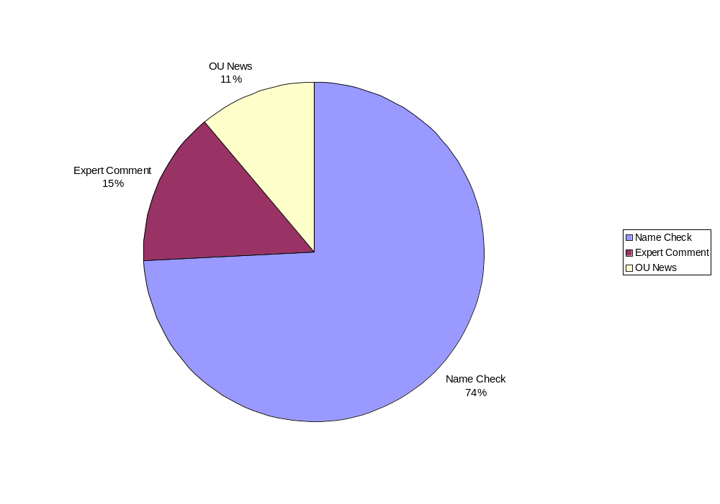
The figures below show the number of news items and source of media coverage for The Open University during the period of this report.

Type of Media | Number of Cuttings
National ‘quality’ papers | 101
Other National papers | 36
TES/THES | 11
Local and Regional papers | 427
Magazines (general interest, specialist and trade) | 137
Radio | 72
Television | 5
Others (incl. web) | 407
Total | 1196

The UK regional media continued to be the greatest source of OU news coverage with 37% but this was closely followed by web based stories with 34%. The “National: Quality papers” and “National: Others” categories made up a total of 11% of the coverage, less than in the last period (Feb 06 to Apr 06). See Chart 7.3.2.

Chart 7.3.2: Media coverage by media type – June 06 to September 06
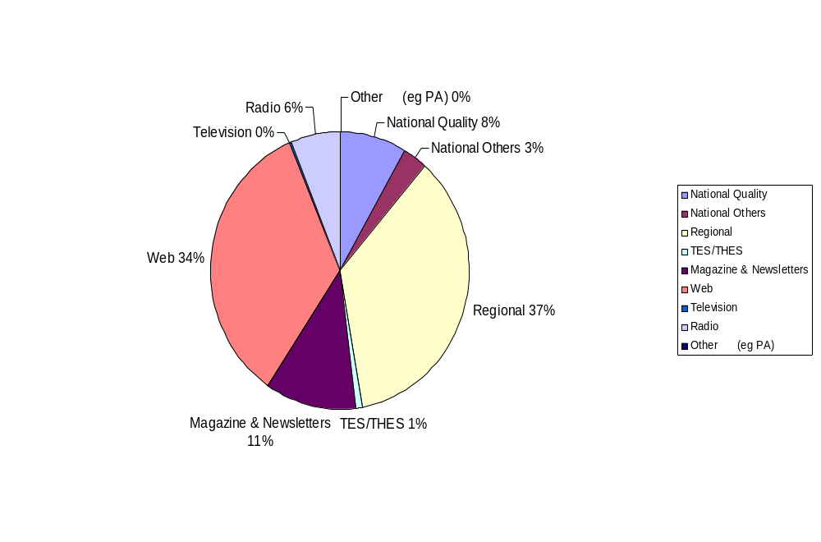
The quantity of media coverage the Open University has received since April 2003 has been trending upwards. In the last year or so however this has levelled off. Increased competition for media space combined with ongoing staffing changes in the OU media relations team has contributed to this trend. See chart 7.3.3 below.

Chart 7.3.3: Open University media coverage, April 2003 to September 2006
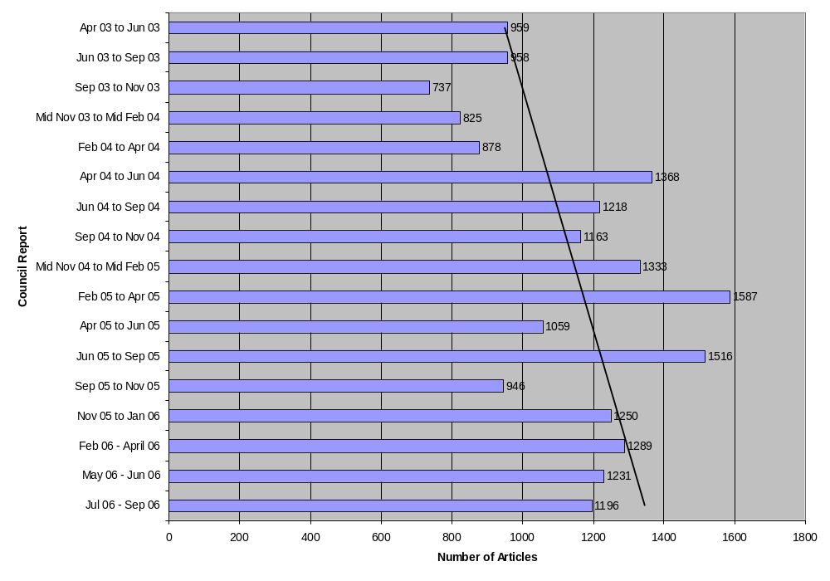7.4 The Media Relations Office
The Open University Media Relations team, part of Communications, is made up of:

Neil Coaten, Head of Media Relations n.d.coaten@open.ac.uk x 52580

Louis De La Forêt, Media Relations Officer l.delaforet@open.ac.uk x 53256

Guy Bailey, Media Relations Officer g.r.baileyopen.ac.uk x 53248

(This Report compiled by Guy Bailey with support from Luke Beaman of the Communications Unit)

