

Media Coverage Report to the Council

Media Coverage for The Open University,
June 25 2005 – September 5

Produced by the Media Relations team, part of the University’s Communications Group,
September 2005

 Executive Summary

The following report summarises the media coverage the Open University received between June 25 2005 and September 5 2005.

The focus of the Media Relations team over the period has been on various strategic initiatives to develop and reinforce a favourable media and public profile for the University particularly in the corporate and political sphere, and support the University’s ongoing student recruitment efforts.

Some of the key media outcomes have included:

- Communication over policy development and the OU’s position

The new higher education fees regime continued to make news headlines and the OU’s position on the issue was communicated in a range of ways through the media. One of the key outcomes was a Financial Times interview with Professor Brenda Gourley about how ‘top up’ fees will impact on part-time students and institutions such as the OU. In a large feature the VC and PVC (Strategy, Planning and External Affairs) discussed OU policy and outlined how flexible learning as delivered by the OU could be the answer for institutions which have been forced to discontinue some key subjects and courses. (Note: These Financial Times articles appeared on 12 September 2005 – after the period covered by the rest of this report).

- Media coverage of the Younger Students strategy

The growing proportion of younger students enrolling in OU courses led the University to specifically market and promote itself this year as a higher education option to school leavers. A national and regional media strategy to support the Younger Students Marketing and Recruitment Campaign was designed and implemented. Coverage was achieved in a several wide-circulating national and regional media including the Independent, Guardian Unlimited online, the Evening Standard, BBC TV East Midlands local news, and BBC News online.
- Media support for the Powering People campaign

The OU’s latest student marketing and advertising campaign “Powering People” continued to be promoted through the media receiving several mentions in notable marketing publications.

- OU/BBC

The evolving partnership between the OU and the BBC received widespread media attention in a number of titles including the Times, the Scotsman and Broadcast magazine as well as in other local and regional media.

July through to early September is generally, in media terms, a less active period. This has been less true for the OU this year. However OU media coverage during this period was higher than in 2004 and significantly higher than for the same period in 2003. Part of the increase in media coverage was due to two major OU/BBC series, Journeys from the centre of the Earth and Coast both of which gained widespread media attention.

Introduction

Media coverage for the Open University, June 25 2005 – September 5 2005

SECTION 1 INTRODUCTION
  - Contents
  - Media Relations Office
  - News releases issued
  - Media enquiries
  - Media coverage

1.1 Contents

Section 2 Report notes 5 3 Media coverage: period comparison 6
4 OU news and developments 8
5 Negative and contentious coverage 9
6 Student Access & teaching 10
7 Research & related comment 12
8 News from the regions 13
9 Broadcast features 15
10 And finally … 16

1.2 The Media Relations Office

The Open University Media Relations team, part of the university's Communications Group, is made up of:

Peter Giesinger
Head of Media Relations p.c.giesinger@open.ac.uk 53343
Eulina Clairmont
Media Relations Officer e.clairmont@open.ac.uk 53248
Neil Coaten
Media Relations Officer n.d.coaten@open.ac.uk 52580
Louis De La Foret
Media Relations Officer l.delaforet@open.ac.uk 53256
Ann-Marie Hamill
Media Relations Officer a.m.hamill@open.ac.uk 55026

1.3 News releases issued

During the 8-week period covered by this report, 22 news releases were issued by the Media Relations team. Subjects included:

- IT Foundation Degree
- The Open University gets walking on the coast (main media release plus six regional specific media releases)
- Word4Word - The changing Linguistic Landscape of the UK
- 20% of new student enrolments at the OU aged 24 or under
- NASA hopes to get photo-op of Beagle
The Open University gears up to welcome A-level student enquiries
- OU & BBC co-productions: The Slavery Business, Ever wondered about Food, Material World and Coast.
- Significant Rise in Students Aged 25 and Younger (regional specific media releases)

Copies of news releases issued by the Media Relations team can be downloaded at www.open.ac.uk/media/

1.4 Media enquiries

The figures below show the number and source of media enquiries received by the media relations office during the period of this report (June 25 2005 to September 05 2005).
From newspapers (national, TES and THES) 35 From newspapers (local and regional) 20 From magazines (general interest) 2 From magazines (specialist and trade press) 23 From radio 30 From television 12 From others (including website operators) 17 TOTAL 139

The number of media enquiries received were similar to same period in 2004.

1.5 Media coverage

The figures below show the number and source of media coverage for The Open University during the period of this report (June 25 2005 to September 05 2005).

In national newspapers 195
In regional newspapers 796 In TES, THES 16 In specialist and trade titles 95 In general interest magazines 34 Radio: local and national 25
Television 8
Others including websites 392 TOTAL 1561

Report notes

SECTION 2

This report has been categorised into various themed sections and the coverage has also been linked to the University’s strategic priorities:

- Ensure fair access for all;
- Respond to students’ & customers’ needs;
- To lead the learning revolution;
- Focus research activity;
- Work in partnership;
- Think global, act local.
- Re-invigorate the brand;
- Generate more income from different sources;

- Ensure cost & quality management;
- Diversify & develop our staff.

This report is collated according to the following themes:

- OU News and Developments
- Negative and Contentious Coverage
- Student Access and Teaching
- Research and related comment
- News from the Regions
- Broadcast Features
- And Finally

This report also includes a comparison of the level of media coverage that the University has attracted during the period of this report to the level for previous equivalent periods.

Publication of the Open Eye pages in The Independent (which appears on the first Tuesday of each month) continued during the period of this report. Open Eye is the monthly bulletin of the Open University alumni community. Information about latest coverage can be found at the alumni website at www.openlink.org

Media Coverage: period comparison

SECTION 3
Introduction

Chart 3.1 shows the number of media articles and references to the OU during the period November 2001 to the start of September 2005. It shows the total number of articles and references recorded for each Media Coverage Report to the Council.

The chart continues to shows a general upward trend in the number of articles and references recorded.

Chart 3.1: Media Coverage of & References to The Open University, November 2001 to
September 2005

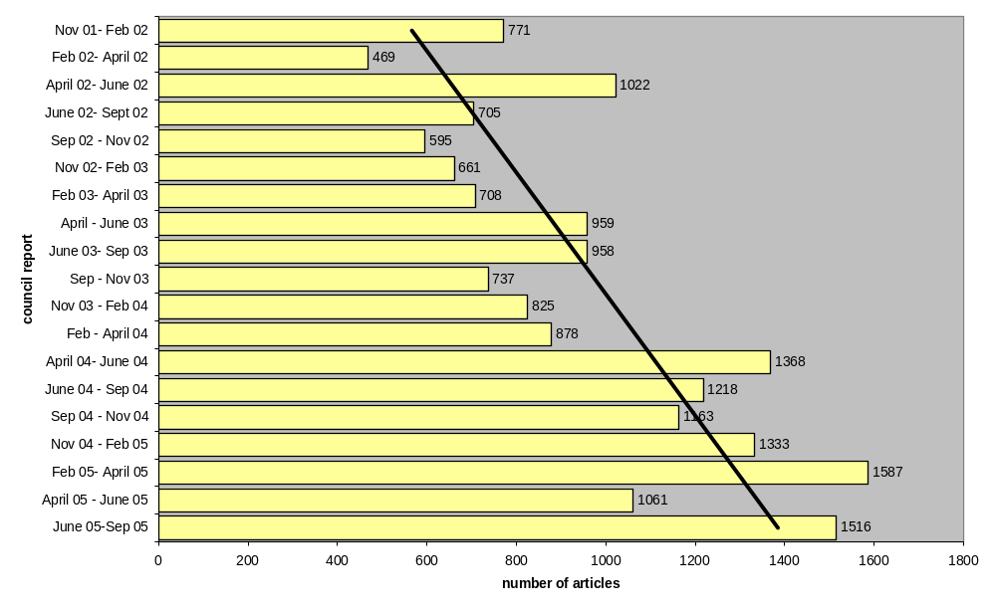

Chart 3.2 (on the following page) shows that the amount of media coverage the OU has received in the period June to September has progressively increased over the past four years.

Chart 3.2: Media Coverage\References for the OU during the June to September period – comparing 2002, 2003, 2004 and 2005

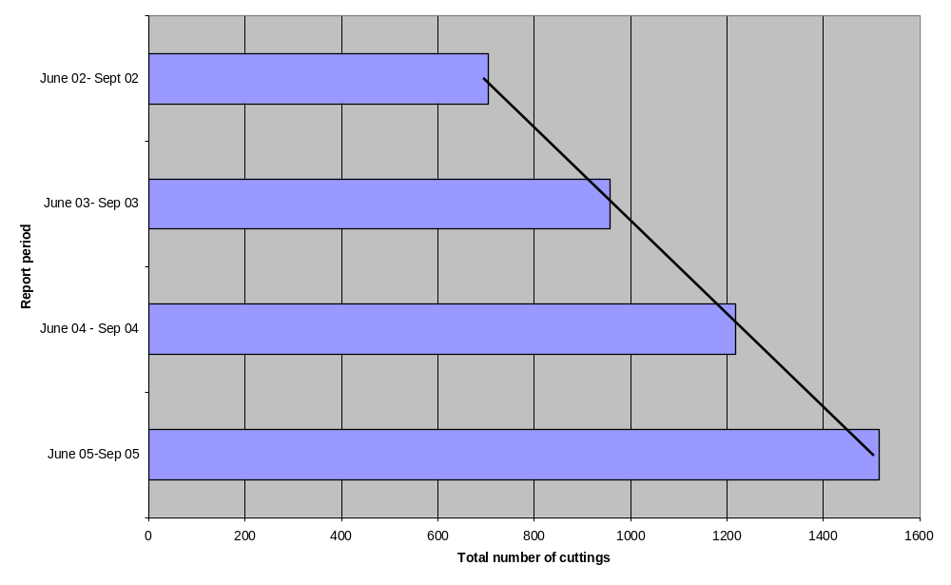

Chart 3.3 (below) illustrates the type of media featuring the Open University. For June 05 to September 05, the majority of coverage (53%) was in regional press, followed by web coverage (26%) and national media (13%). There has been an increase of more than 11% in regional coverage and a 1% increase in national coverage since the last report. The large amount of coverage for the flagship OU/BBC series Coast accounts for a significant proportion of this increase in regional coverage.

Chart 3.3: Type of media that The Open University was represented in during the period to June 05 to September 05
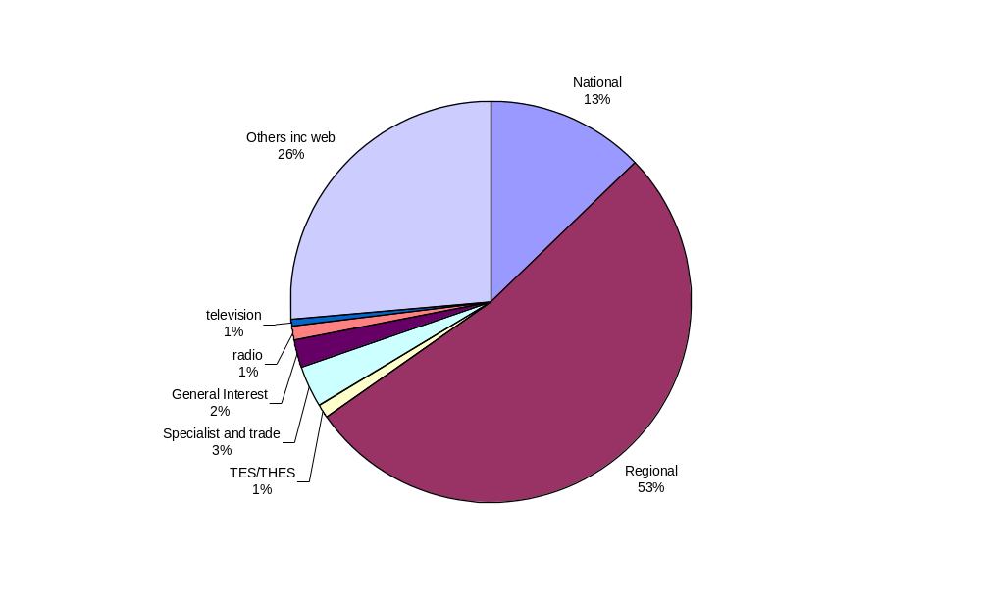
OU news and developments

OU’s strategic priorities: SECTION 4
- Re-invigorate the brand
- Ensure fair access to all
- respond to students’ and customers’ needs
- To lead the learning revolution
- Generate more income from different sources

Record numbers of young people are choosing to study with the OU, reported a number of titles. The articles – resulting from the efforts of the Media Relations team – complemented an ongoing student marketing and advertising campaign aimed at students who were going through the Clearing process for entry to university this year.
The Independent; the Scotsman; BBC TV East Midlands Today; Swindon Evening Advertiser; BBC News online; the Evening Standard

In an opinion leader column about the issue, The Independent wrote: “… Savvy teenagers, anxious to minimise their debt and work full-time while they study, know that the OU makes sense …”

The University’s Young Applicants in Schools (YASS) Scheme – which enables secondary school students to study at undergraduate level alongside other lessons – was the subject of a national press article as well as other media coverage. Sunday Telegraph

YASS was also referred to in a more general article about opportunities offered to
A-level students to study at undergraduate level. Times Higher Education Supplement

The scheme was also the subject of regional press interest.
North-West Evening Mail; Barrow-in-Furness

Fourteen-year-old Yinan Wang, who has been offered an immediate place at the University of Oxford, also took an Open University course for mathematics, reported national and local media. Daily Mail; The Independent; The Sunday Telegraph;
The Weekly Telegraph; Kilburn Times

An opinion article by Professor David Vincent, Pro-Vice-Chancellor (Strategy, Planning and External Affairs), argued that higher education policy must reflect socio-economic changes.
The House Magazine.

The award of a National Teaching Fellowship to Andrew Northedge, of the Faculty of Health and Social Care, was featured in Milton Keynes media. His The Good Study Guide has sold more than 420,000 copies. MK News

The University’s “Powering People” television advertisements won praise from a specialist marketing title, which described the adverts as a “masterclass in clarity”. Another marketing title reported on the launch of the campaign.
Direct Marketing International; Precision Marketing

An honorary fellowship was awarded by the Royal Academy of Engineering to Professor Michael Jackson, Visiting Professor in the Faculty of Mathematics and Computing.
Times Higher Education Supplement

National and regional news reported widely that Professor Colin Pillinger, of the Planetary and Space Sciences Research Institute, has multiple sclerosis (MS).
Daily Mirror; The Guardian; The Sun; The Times; Metro London; BBC News online; Bristol Evening Post; Chester Evening Leader; Dorset Echo; Glasgow Herald; Heartland Evening News; Leicester Mercury; MK News; Western Daily Press; Western Mail

TeachandLearn.net – the university’s online continuing professional development tool for teachers – was reviewed in a specialist title. Professional Development Today

The launch of the university’s Centre for Continuing Professional Development was reported in the business press. Business Weekly

Negative and contentious coverage

SECTION 5
The ongoing union negotiations over the assimilation to the new pay system for OU associate lecturers continued to attract coverage in the specialist press. The THES carried several stories - including an initial report about the proposed pay deal; a subsequent report about a ballot of associate lecturers who are members of the Association of University Teachers; and a follow up story about an emergency general meeting of the union branch that discussed the administration of that ballot.
Times Higher Education Supplement; Guardian Unlimited Online

The outcome of an employment tribunal brought by a former OU course manager was reported by local media in Milton Keynes.
MK News

Student Access and Teaching

SECTION 6
OU’s strategic priorities:
- Ensure fair access to all
- respond to students’ and customers’ needs
- to lead the learning revolution

6.1 E-learning
6.2 Life-long learning
6.3 Students
6.1 E-learning

Described as “long at the forefront of online learning’, a news report outlined how the OU has developed its own solution for streamline meetings – whiteboards. Using whiteboards which can be scanned and contents e-mailed out, enabling participants to hold virtual, interactive meetings. The Sunday Times

A detailed and favourable article described the benefits of OU supported online distance teaching, enabling students to get ahead without having to give up full-time work. The Guardian

6.2 Life-long learning

Among the OU courses/student initiatives referred to by both specialist titles and national media were the following:

MBA Fleet News, The Guardian
Learning Disabilities The Mail on Sunday
Astronomy Metro
The Business School – various courses listed; Norwich Evening News
English Literature Cumberland & Westmoreland Echo

Some of the regional and national media which described lifelong learning at the OU included:

An article which looked at sixth-formers who want ‘extra strings for their academic bows’ who are taking up OU courses. The Independent

A story describing 10 reasons not to fear retirement; lists the OU as an option for continued self development in a person’s golden years. The Daily Mirror

A news item profiling a 19 year old beauty pageant contestant who is studying an OU maths course. Southend Evening Echo

GNER sponsored railway managers who graduated with certificates or diplomas in management studies The Northern Echo

A two page spread on students who have opted out of traditional university for financial reasons and lists the OU as a sound alternative option. The Independent

6.3 Students

The ongoing national and regional OU Graduate Publicity Campaign designed and implemented by the Media Relations team each year from April to September continued to generate media coverage. Some of the media stories listed below resulted directly from that campaign.

Among the graduates and alumni whose OU studies were referred to in national press articles were:

- Prison warden Abu Bakr Nazir, who was sponsored by the prison service.
- Ex-bus driver Paul Waddington who overcame major illness to get his degree.

Among graduates and alumni whose OU studies were referred to in regional press and specialist articles were:

- All Fleet Services newly appointed senior operations manager Janet Parkin.
- Catriona Nestor graduation photo, after completing OU BSc degree.
- Coldstream Guard Robert Dickson.
- Geraint Griffiths was awarded his Med.
- Pat Ryder continued to study for her degree during treatment for cancer and now fundraises for cancer research and works for Manchester University.
- 76 year old Rev Daphne Bradford received her degree in Church History after her education was cut short due to WWII.
- Fire Station Manager Victor Spence, 42, from Armagh, whose employers sponsored his science degree. His achievement has greatly increased his chances of promotion.

Among current students who referred to their OU studies in national, regional and specialist press articles were:

- 19 year old maths student Lucy Brooker who is competing to be Miss Essex.
- Young mum Naomi Clarke taking course in health after her baby’s illness.
- Prisoner Dwayne Roman is currently studying with the OU to further his chances of rehabilitation when he is released.

Research news

SECTION 7
OU Strategic priorities
- Focus Research Activity

Faculty of Technology

Dr Debbie Ellen, OU research fellow and Clem Herman co-authored a report about female Microsoft engineers. The report sought to discover if Microsoft training in a women-only environment would encourage more women to become accredited engineers.
Computer Reseller News
Clem Herman also provided comment on women returning to careers in science and technology after career breaks. Biomedical Scientist
Faculty of Health and Social Care

Young people experiencing bereavement should be offered better support to help them cope according to research by Jane Ribbens McCarthy.
Wolverhampton Express and Star
Faculty of Science

Restrictions on the use of brain-enhancing chemicals that can improve intelligence prompted debate including comments from Professor Steven Rose, director of brain and behaviour research at The Open University who said: “These new technologies open the way to mind manipulation and to the creation of a society that has indeed moved beyond freedom and dignity.” Sunday Times

Professor Steven Rose of The Open University commented on the rush by scientists to clone humans, he said, “pushing us into human experimentation before necessary prior controls have been carried out with animals.” The Guardian

Professor Monica Grady was quoted as saying “We are going to see the pristine material that formed the solar system,” in an article about NASA’s Deep Impact mission crashing into a comet. The Week

Britain has the ability to finance, develop and launch its own mission to find life on Mars according to OU Professor Colin Pillinger in his campaign to seek support from the European Space Agency for a 2011 mission. Laboratory Update

NASA’s latest mission to Mars will watch the weather, may find future landing spots and may find the lost Beagle 2 lander. “…it’s going to be able to make the best search there has been,” said Professor Pillinger. The Scotsman

Professor Caroline Pond, of the Department of Biological Sciences, provided a published response to a question about the survival ability of polar bears if transferred to Antarctica. New Scientist
Faculty of Arts

The launch of an online database of Old Bailey archives – in which the OU is a partner university – was featured in a national title. The Weekly News

The OU Business School

To bring about a step change for the industry a study, carried out by The Open University Business School, identified the key drivers from the client, the employer and the customer viewpoint. Cleaning and Hygiene Today

Martin Upton, Open University Business School economist and researcher in financial risk management, sees no need to panic over UK housing market prices in the coming year.
The Business

More than a quarter of Oxfordshire small firms either do not want to grow or add more staff…according to the latest Quarterly Survey of Small Business put together by NatWest and the Small Enterprise Research Team based at The Open University Business School.
Kent Business; Oxford Mail
Companies were invited to participate in an on-line survey by the SERTeam, a small research charity at The Open University Business School.
Professional Oversight Board for Accountancy

Half of small firms claim to be against globalisation, but admit they do not always buy British – research undertaken for Lloyds TSB Business by the Small Enterprise Research team at the Open University. The Mail on Sunday

Recent research carried out by NatWest and the Open University revealed that about 66 percent of small business owners are members of one or more business or trade association, networks or clubs. North Belfast Telegraph, South Belfast Telegraph

Professor Gary Slapper, Professor of Law, continued a regular column on legal issues. The Times

Dr Judith Margolis, senior lecturer at the OU Business School, provided comments on marketing resource management. B2B Marketing

News from the regions

SECTION 8 NEWS FROM THE REGIONS

Media coverage highlighting OU regional activities during the period of this report included the following.

Region 02 – The Open University in the South
● The university’s participation in the AimHigher partnership for Milton Keynes, Oxfordshire and Buckinghamshire.

Region 03 – The Open University in the South-West
● Information events for potential students.

Region 05 – The Open University in the East Midlands
● Information events for potential students.

Region 06 – The Open University in the East of England
● The university’s participation in the i10 network, whose objective is to ensure that businesses benefit from the knowledge and expertise in the region’s universities;
● Students participating in the Young Applicants in Schools Scheme.

Region 08 – The Open University in the North-West
● Participation in jobs and education fairs.

Region 10 – The Open University in Wales
● The regional centre’s proposed move to new premises in Cardiff.

Region 11 – The Open University in Scotland
● The validation of degree courses offered by the University of the Highlands and Islands;
● Information events for potential students.

Region 12 – The Open University in Ireland
● Information events for potential students.

Region 13 – The Open University in the South-East
● The presentation of awards, including some from the OU, to a group of East Sussex County Council staff.

Broadcast Features

SECTION 9 BROADCAST FEATURES
13.1 Corporate coverage
13.2 Coverage for BBC/OU programmes

OU Strategic priorities
- Work in partnership

13.1 Corporate coverage

The evolving partnership between the OU and BBC was the subject of several key national, specialist and regional news articles. The stories focused on the move from late-night OU course-specific broadcasts to multi-channel and primetime programmes.
The Times; BBC 3 Counties Radio; ITV Central South News; Broadcast magazine; MK News

13.2 Coverage for BBC/OU programmes

Desperate Midwives

With the birth rate rising for the first time in 20 years coupled with a national shortage of midwives, a new BBC/OU series, Desperate Midwives, lifted the lid on modern midwifery in Britain. The following statistics for press and broadcast coverage for Desperate Midwives have been recorded:

TV listings magazines previews and features
National press previews and reviews (TV supplements and daily TV pages) | 10
National press articles (non-TV sections) | 20
Regional press previews and reviews (TV supplements and daily TV pages) | 76
Regional press articles (non-TV section) | 12
Specialist titles (e.g. history magazines) | 2
Broadcast features
Other (web etc)
TOTAL | 140

- None of the cuttings mentioned the OU
Journeys from the Centre of the Earth

Journeys from the Centre of the Earth was a six-part Open University and BBC co-production, first shown on BBC4 in 2004 then on BBC TWO from July 2005. The following statistics for press and broadcast coverage for Journeys to the Centre of the Earth have been recorded:

TV listings magazines previews and features | 12
National press previews and reviews (TV supplements and daily TV pages) | 4
National press articles (non-TV sections)
Regional press previews and reviews (TV supplements and daily TV pages) | 125
Regional press articles (non-TV section)
Specialist titles (e.g. history magazines) | 1
Broadcast features
Other (web etc) | 4
TOTAL | 144

- Of the total number of cuttings two mentioned the OU.

Stardate: Deep Impact

Stardate: Deep Impact was broadcast from mission headquarters at JPL in California, bringing to viewers the images taken by the spacecraft as the impactor was released and smashed into the comet Tempel 1, giving a unique view inside a comet and allowing a greater insight into what makes up the earth. The following statistics for press and broadcast coverage for Deep Impact (coverage of the programme specifically, not the event itself which received extensive media coverage) have been recorded:

TV listings magazines previews and features
National press previews and reviews (TV supplements and daily TV pages) | 1
National press articles (non-TV sections)
Regional press previews and reviews (TV supplements and daily TV pages)
Regional press articles (non-TV section) | 1
Specialist titles (astronomical newsletters etc)
Broadcast features
Other (web etc)
TOTAL | 2

While the Star Date programme itself did not achieve widespread media coverage, the event itself did - including a number of interviews with OU researchers who commented on the mission in the media. The Guardian; The Sun; Shropshire Star

Coast

- The United Kingdom coastline stretches unbroken for 19,000 kilometres - and that's without counting Northern Ireland or the thousands of islands. The 13 part series, Coast, on BBC TWO attracted significant audiences and extensive media coverage including during the period of this report. However media clippings continue to be tracked and monitored and a detailed report on the coverage of this programme will be included in the next Media Coverage Report to the Council. To date none of the cuttings mentioned the OU.

And Finally …

SECTION 10 AND FINALLY …

The gossip and tabloid press gained significant mileage out of the Open University, when a former pop singer, now classical musician Myleene Klass, let it be known she had registered for an OU course in astronomy, the news stories varied widely.

She has enrolled in an OU degree course in astronomy. “I’d like to be able to use this knowledge to make science programmes for TV.” She reportedly is lined up to front a new version of Tomorrow’s World next year. Hello!

Myleene has enrolled in an OU degree course in astronomy and is “writing extraterrestrial music which she plans to broadcast as part of a special science project. The star-loving beauty began working on the special commission for the Venus probe project after befriending scientist Professor Colin Pillinger …” Scottish Daily Record

Actress Lindsey Coulson admits to hoping to one day take an Open University degree.
Cambridge Evening News

In an article on “17 ways to lengthen your life,” a magazine lists at number four: “Better educated people live longer. It’s never too late, so sign up for an evening class or Open University course now.” Yours magazine

A newspaper astrologer recommended studying at the OU as part of his daily horoscope prediction/advice column. Patrick Arundell told Aquarians: “the internet or Open University can be splendid ways to widen horizons.” The Evening Times

