Media Relations Office
Communications Group
The Open University
Milton Keynes
United Kingdom
MK7 6AA
t +44 (0)1908 653343
f +44 (0)1908 652247
e Press-office@open.ac.uk
w www.open.ac.uk/media/




News

For the attention of: News Editors
Thursday November 15 [PR5429]

Sir Gerry Robinson returns to the NHS on BBC TWO this December
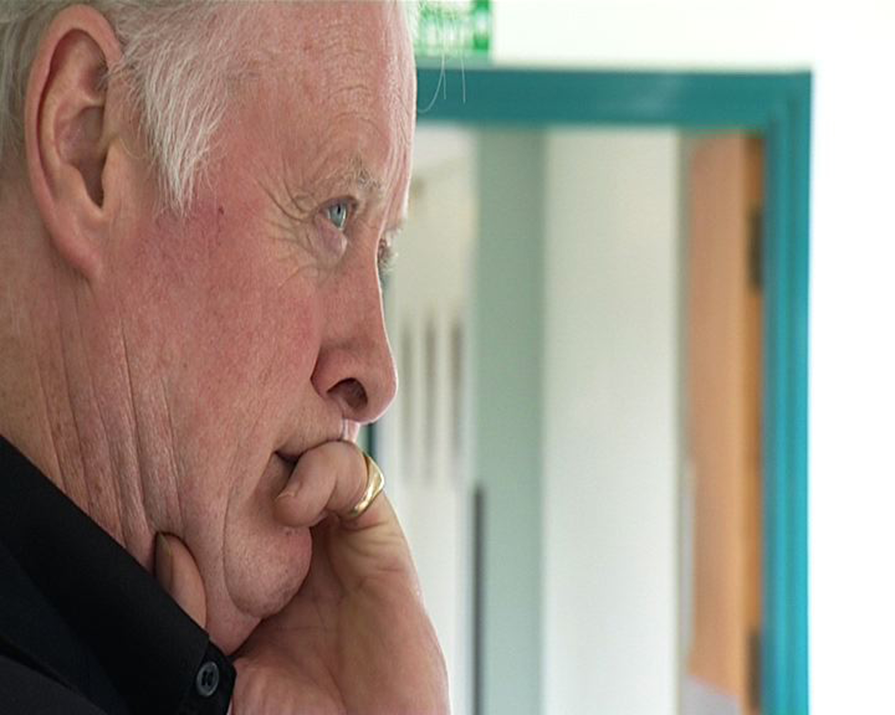
“Can Gerry Robinson Fix the NHS? – One Year On”
TX: BBC TWO, 9pm, Wednesday 12 December
Sir Gerry Robinson is returning to the scene of one of his most daunting challenges – to reduce waiting lists at an NHS Hospital in Rotherham, South Yorkshire, within six months and with no additional funds at his disposal.
His challenge was documented in the three-part, fully-funded Open University series ‘Can Gerry Robinson Fix the NHS?’ broadcast on BBC TWO in January 2007.
In ‘One Year On’, Sir Gerry returns to Rotherham General Hospital – in this new programme, also fully-funded by The Open University, to see if the ideas and initiatives developed were still in place 12 months later and if they had made a difference.
Through his original work at the hospital, Sir Gerry found barriers to change and tensions between consultants, managers and executive staff. The Rotherham NHS Foundation Trust is a massive organisation, with dedicated staff but the NHS is a constantly changing organisation that has to be run more like a business than a service. Sir Gerry needed all of his skills, experience and tenacity to help them implement this crucial transition.
‘One Year On’ shows Sir Gerry’s trepidation as he wonders how effective his reforms have been and even if they are still being employed.
The results are surprising and positive.
Sir Gerry finds performance improvements, reduced waiting times and a new ‘can-do’ attitude from staff and management. He meets old faces and sees how the management and staff adapted to new ideas with energy and enthusiasm. Even he is surprised to see the extent of his input and impetus generated.
Rotherham Chief Executive Brian James has continued to follow Sir Gerry’s advice about getting out and about around the hospital, meeting his staff and maintaining a visible presence in the organisation. Relationships between managers and consultants have improved significantly. The other headline results include:-
- In 2006, many operating theatres were left unused at any one time. Now, there is a fully operating back-to-back surgery system in place.
- 2006 waiting lists have been reduced in all the areas Gerry looked at – Paediatrics (out-patients); Orthopaedics (in-patients); Ophthalmology (in-patients); and Endoscopy.
- A new performance improvement initiative by Chief Executive Brian James called Rapidly Improving Services for Everyone (RISE) has given staff autonomy to fix localised problems and improve their service.
Sir Gerry said: “One unexpected side-effect of my time at Rotherham is that I now give regular talks to NHS managers and leaders throughout the country about achieving results.
“Frankly, if you haven’t got people feeling great, not good, great about what they are doing, then you are failing to manage.”

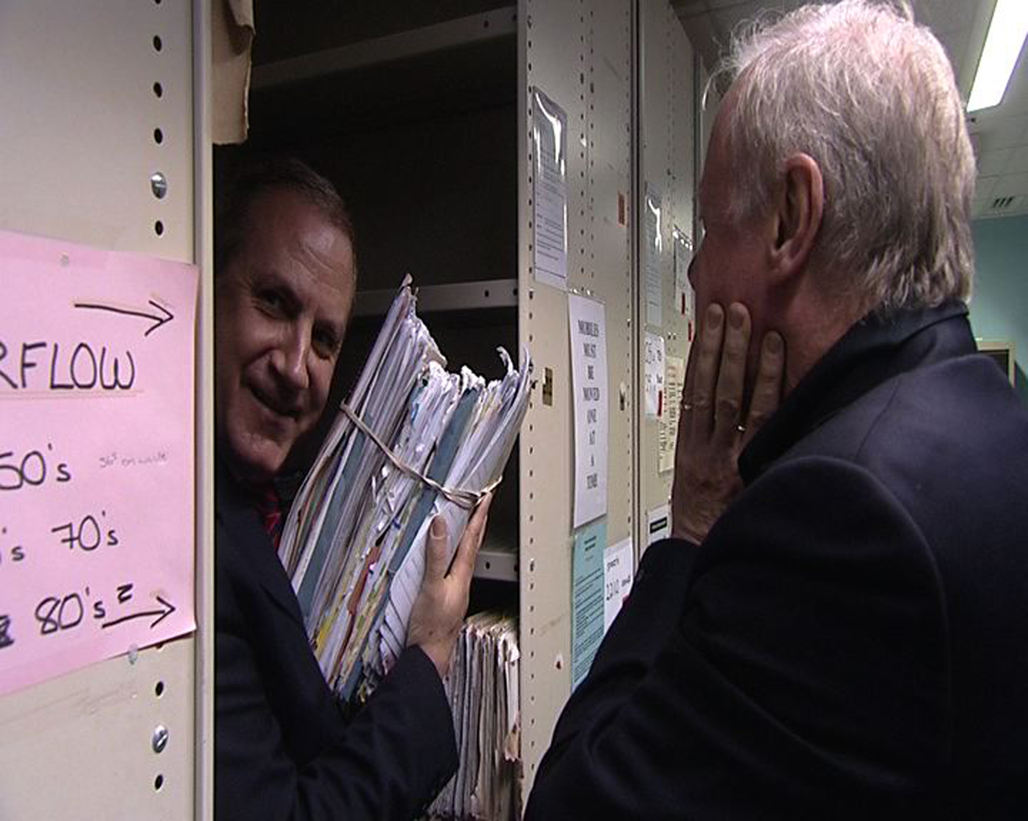
Sir Gerry is speechless as Chief Executive Brian James shows him just one patient’s case notes.
The news isn’t all good. Sir Gerry is visibly frustrated at new Government initiatives which threaten the future viability of this trusted hospital, despite its performance improvements.
The patient’s records systems are paper-based and he is visibly shocked as he sees the volume, space and manpower required to update the system. When asked about computerisation, Sir Gerry is told about the promised new multi-billion pound national IT project, which is already over two years late and causing increasing difficulties in managing hospital records.
Sir Gerry also finds that another new government initiative has led to the creation of a £12m ‘walk-in’ polyclinic, providing some of the same services as the hospital, to be built only two miles away. He hears how many staff and patients fear this could put many existing hospital services in jeopardy.
His findings lead Sir Gerry to the singular conclusion that “the NHS – the most important institution in the country - has to be separated from Government”.
Professor John Storey, from the OU Business School and academic advisor to the programme, said: “The programme puts the difficulties of a single hospital in the wider context of the NHS system as a whole. It is able to reveal some of the key tensions in the current NHS redesign as they are experienced at a local level.
“There are the mixed messages about the need for hospital trusts to compete and yet also to collaborate, the message about local autonomy as a Foundation Trust and yet continuing multiple top-down directives and priorities, and, most starkly, the apparent massive uncertainty expressed by both the hospital trust and the primary care trust Chief Executives, about the purpose, role, value for money and consequences of the new community clinics designed to divert some of the work from the District General Hospitals.”
Professor Shirley Reveley, Dean of The Open University’s Health and Social Care Faculties said: “It is very good to see the obvious change in attitude of some of the key individuals at Rotherham General Hospital since the first series. This programme shows enhanced teamwork and a willingness to embrace change that was not apparent in the previous programme.
“Brian James is emerging as a “people’s manager”; more visible to the staff. Not all staff members agree that Brian in now clearly in charge but there is now an impression that Brian’s personal involvement with staff has had an empowering effect on some individuals and groups of staff and this provides the confidence for change to happen. “It is not known however, how staff morale and confidence will be affected by the suggestion that the new walk-in centre located nearby could jeopardise some of the hospital’s services.”
There will be the chance to debate the issues raised by the series in an online forum hosted on www.open2.net after the programme has broadcast.

Editor’s Notes

‘Can Gerry Robinson fix the NHS? – One Year On’ is a fully-funded Open University production for BBC Two.
It will broadcast at 9pm on Wednesday December 12 on BBC TWO.
The Executive Producer for the BBC is Dinah Lord and Executive Producer for The Open University is Emma De’Ath. The Open University academic consultants are Professor Shirley Reveley and Professor John Storey.
The Open University and BBC have been in partnership for more than 30 years, providing educational programming to a mass audience. In recent times this partnership has evolved from late night programming for delivering courses to peak time programmes with a broad appeal to encourage wider participation in learning.
All broadcast information is correct at time of issue.
For Preview DVDs, images and interview requests please contact Guy Bailey or Kath Hardwick, contact details below
Resources
Related Courses and programmes from the OU Business School:-
- Masters in Public Administration (MPA)
- B700 Managing Performance and Change
- B615 Professional Certificate in Management
- C40 Professional Certificate in Management (Health and Social Care)
- G05 Foundation Degree in Health and Social Care
- B47 BA/BSc (Hons) Nursing Studies
- D64 Professional Diploma in Management
- K303 Managing Care
- K307 Managing Health & Social Care
- K822 Leading Healthcare
- K311 Providing Public Health

Websites:
Courses: http://www.open.ac.uk/courses
Programmes: http://www.open2.net
OU Business School: http://www.open.ac.uk/oubs
Media Contacts
Guy Bailey g.r.bailey@open.ac.uk +(44) 1908 653248
Kath Hardwick k.hardwick@open.ac.uk +(44) 1908 655026

